Contract for a foal. Joni’s Misty Moon
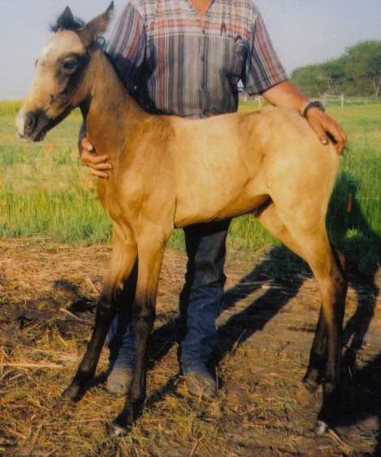
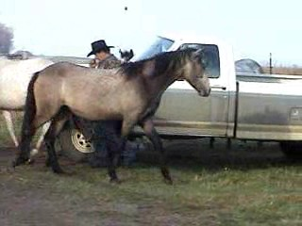
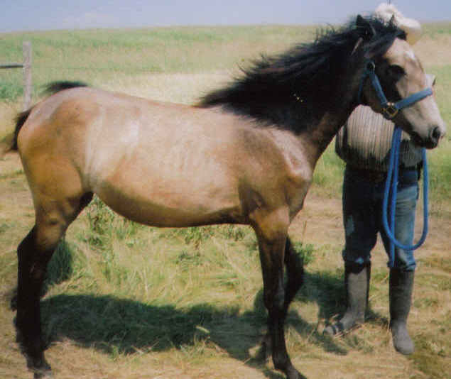
Mare Not Buckskin PFHA# 44,253
For Sale. 14.2hh+ Mare, Born: 6/10/ 2004

Website www.jonilund.com

Canario I Cometa #102061 by ?
# 102069 La Califa # 102066
yr. 2006 Canario II Dinamita unknown
# 103024 # 103020 unknown
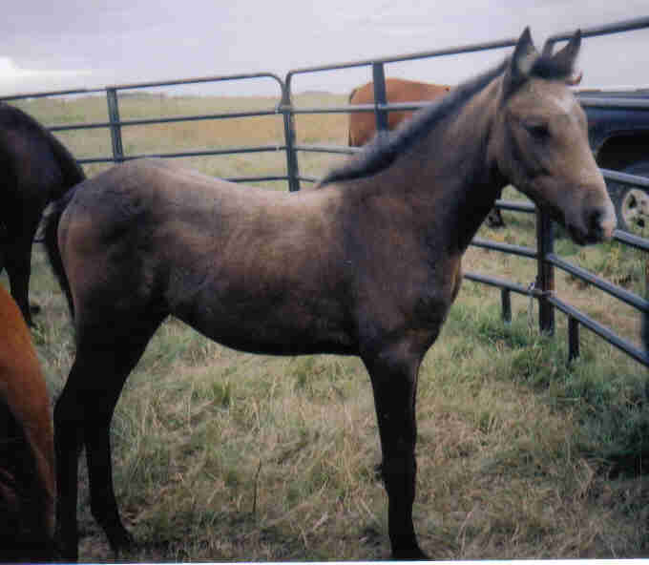
yr 2005 Coral LaCE Cabuyero unknown
#1,436 #70258 Bay Dama # 103025 unknown
#102558 Pluma unknown
# 102339 unknown
Coral’s Don Dorado de Vez Triunfo Batalla #102059 by Dulce Sueno
PFHA # 11,481 , #80303 Frio Viento #102168 Estrella # 102166 by Batalla by Dulce Sueno
Yr 2004 Palomino #69883 Maria Luisa El Huerlano # 102259 by Faraon I
Hija de los Vientos # 71247 La Crema #102260 by Batalla by Dulce Sueno
^ # 2,424 white Cori Marineo # 102099 by Dije
/ Gitano Viento # 102151 Santa Elena # 102695 by Dulce Sueno
/ # 103484 Adorna Triunfo #102168 by Batalla by Dulce Sueno
/ # 102916 Riosa # 102480 by Wahoo by unknown
Silencio Quieto de Luneta Cometa I Resorte I # By Jupiter
PFHA # 30,622 Rey Cometa # 102375 La Gaviota # by unknoown
Cremello with Dun factor # 102382 La Pianola Califa I # by unknoown
\ Very NICE mover & Largo #102379 La Nieta # by unknoown
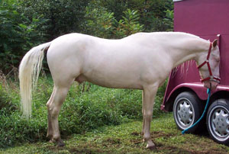
\ Lunares Carnaval Carey # by unknoown
\ #465 Gray #102773 La Rifa # by unknoown
\ unknown unknown
La Triste # #
Luneta de Omega #.102383 unknown unknown
PFHA # 6,152 gray # #
Peagot unknown
Sundance #102380 unknown
#69286 Madariaga unknown
Cristal #102381 unknown #5,444 Palomino Caonato unknown
Sunset #104264 unknown
#73629 Maria Bonita unknown
#104265 unknown
Representante Capuchino Capuchino Resorte Quarto # 76172 by Resorte III
#86071 Bay #75766 chestnut Capuchina III # 105204 by Resorte Quarto #76172 Motivo Dona Rita Lord # 105585 by Corzo goes back to Resorte I
#86612 Black #76428 Black Sirena # 105586 by Mensajero
Gala Que Tal Criol Que Tal Mahoma # 102310 By Triunfo #102278
#69001 Gray #68988Gray Salpicada # 68982 by Campoalegre
Acero de Plata NPF Guala Plumaje # 102308 by Piel Roja
PFHA # 92698 Grey #68969 Black Celosa # 104943 by Gaucho back to Resorte I
^ Caliente LaCe Munero LaCe Lucifer # 102031 by El Cacque
/ #69721 Black #68825 Gray La Polvora #102032 by Resorte I
/ Caliope Mirabel LaCe Sondar # 102096 by Ese Si by Dulce Suenco
/ #74645 Gray #70223 Bay Piel Canela # 102125 by Guamani by Dulce Sueno Cristina Corinto Conde # 102205 by Presidente by Batalla
DAM #71940 Black #102208 Sorpresa # 102206 by Guamani by Dulce Sueno
Joni’s Westford Dakota Siba Caramelito # 102846 3 lines to Dulce Sueno
PFHA #34,190 #69413 Bay Casimba #71054 sire:Cacique by BatallaDam:Old One by Dulce Sueno
Bay Turned grey Choc Que Tal Mahoma Triunfo # 102278 by Andino # 102271
\ #170 brown Very Nice Largo #102310Brown Mecita de Salgar #102307 by ?
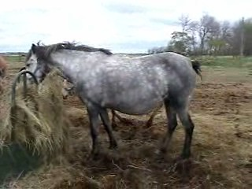
\ Chocante Cabal Campesina Pistolero # 105748 by El Plata # 106721
\ #6,646 Black #102199 Sevillana # 109262 by Oro Negra 108543
\ Escusha Que Tal Hilachas Zipa # 102301 by ?
#93 Black Very tight gaited. #150 Bay Muneca de VI # 102302 by ?
Velvet Mi Lu Cucuracha Estrellas # 102304 by ?
PFHA # 13,193 #102306 Companera # 102305 by ?
Guamani Dulce Sueno # 102037 by Carmelo 103331
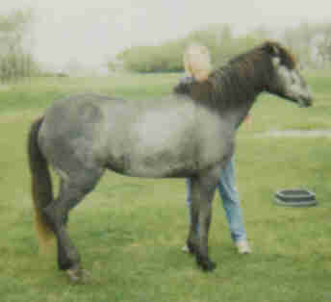
Faeton LaCe #102050 Cordoncilla Alazana #102047 by Patiblanco
#55 Chestnut Piel de Seda (M) Piel de Seda #102065 by ?
Companita LaCe #102107 La Godreau #102106 by Pocholo #140 Black Volare Pincel #102021 double bred Dulce Sueno line
Volacia LaCe #102025 Princess Mora #102018 double bred Dulce Sueno
#931 Brown Veronica LaCe Dulce Sueno II #102048 by Dulce Sueno
#102402 Buena #102401 by Copita by Dulce Sueno
Joni Lund – Equine Services, 1295 1st ST S, Carrington, ND 58421 (701) 652-1986

