For Sale - Colt
Joni’s Dakota Spirit
Paso PFHA# - pending
Born: May 23, 2008

Website www.jonilund.com

Marichal Bolero LaCe by Volare/ Morena
Bandolero Royal_ # 68922 Black Sofia La Negra by Dulce Suneo/ Sofia Alazana
# 1,327 Black, Endora Nino by ? Dulce Sueno
Pegasus Estaban____ # 68971 Black, Col Sierva ?
PFHA # 8,802 Pino Don Miguel Estaban Boricua by Batalla/ Nevada Cosa Differente Estaban # 69849 Roan Ilusion Godreau by Guamani by Dulce Sueno
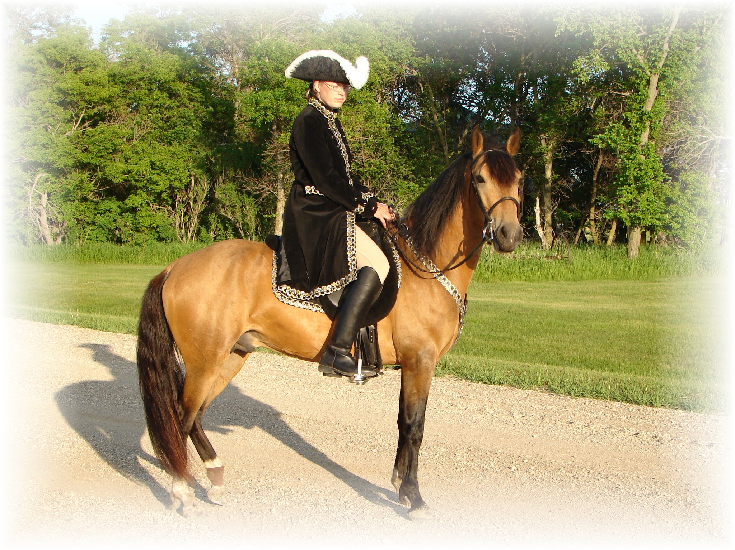
# 1,922; #70744 Pinto Fudia Estaban Danza by Guayama/ Espada
Monteado dePegasusPisadas # 70741 Bay pinto Rosita by Magia Blanca/ Princesa
# 23,618; #91529 Red/Bay tobiano Bolero LaCE Volare by Pincel/Princesa Mora
Campesino La CE # 68824 balck Morena by Gringo/Marianela # 1988 #70810 Bay; PR Dalfia LaCE Muneco LaCE by Lucifer/ La Polvora
Norelle de Encato #68870 gray Dalia LaCe by Gaucho/ La Dalia
#9359 #78181 Bay unknown unknown
Gitana Rosa unknown
SIRE # 2998 #71820 pinto unknown unknown
Future of Pisadas de Oro unknown
PFHA# 44,422 Sonador Ese Si by Guamani / Negra
- APLHA# 8603 Sizcocho LaCE #102096 PR#310 Enriqueta by Copa/ Dona Yin
- Tiger Horse OC#009 #512 #69334 Bay Maravilla LaCE Guamani by Dulce Sueno/Cordondillo Alazana
Tesoro Salago 102124 La Doctora by Dulce Sueno/Cordondillo Alazana
Buckskin #519 #69341 Sombre LaCe Cori by Marinero/ Santa Elena
Buckskin (PR) Lunina LaCE #102152 Palomino Maria Luisa by El Huerlano/ La Crema
Alegria Salago #507 #69329, PR Carina LaCE Rojo by unknown
- #10133 #78955 ¾ PR/ ¼ col #68887 Vieja by unknown sire/ dam
Buckskin Very intelligent Muneco LaCE Lucifer El Cacque by unknown sire / dam
- #3 #68825 Gray #102031 (Col.) La Melva by unknown sire / dam Gwenona LaCE La Polvora Resorte I by Jupiter
- #517 #69339 #102032 (Col.) La Ninfa by unknown sire/ dam Bay? Brown Monona LaCE Furioso (aka Fury) Noche Buena by Dulce Sueno/Estrella
- ½ PR/ ½ col #510 #69332 #102075 (PR) Violeta by Dulce Sueno/ Felipa Bay PurePR Cocoa II Altanero by Caramelo#102033/ ? #102798 Cocoa by Unknown sire/ dam
Capuchino Resorte Quarto Resorte III Representante Capuchino #75766 Capuchina III Resorte Quarto/Capuchina III
# 86071 Dona Rita Lord Corzo/ Soraya
Motivo # 76428 Sirena Mensajero/Balanlaika
# 86612 Criol que tal Mahoma Triunfo/ Mecita de Salgar
Gala que tal # 68988 Salpicada Campoalegre/ Cocoa Cola
# 69001 Guala Plumaje Piel Roja/ La Venus
Acero de Plata NPF # 68969 Celosa Gaucho/ La Oka
# 92698 Muneco LaCE Lucifer El Cacque/ La Melva
Caliente LaCE # 68825 La Polvora Resorte I/ La Ninfa
# 69721 Mirabel LaCE Sondar Ese Si/ Enriqueta
Caliope # 70223 Piel Canela Guamani/ Piel de Seda
# 74645 Corinto Conde Presidente/ Haydee
Cristina # 102208 Sorpresa Guamani/ Color Rosa
DAM # 71940 Siba Caramelito Caramelo/ Canaria
Joni’s Westford Dakota #69413 Casimba Cacique/ Old One
PFHA # 34,190; # 111976 Mahoma Triunfo Andino/ La Chispa
Bay turned Gray 13.1hh to 13.2hh Choco que tal #102310 Mecita de Salgar ?
# 68992 Fino Fino Campesina ?
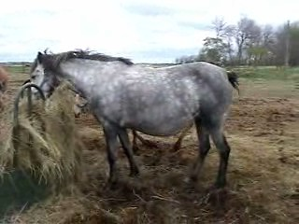
# 102310 ?
Chocante Cabal Hilachas Zipa ?
# 75468 Escusha que tal # 68972 Muneca de VI ?
#68992 Cucuracha Estrellas ?
Velvet Mi Lu # 102306 Companera ?
# 82015 Guamani Dulce Sueno Caramelo/ Mosqueda
Faeton LaCE #102050 CordoncilloAlazana Patiblanco/ Cordoncillo Zaina
#68877 Piel de Seda Piel de Seda ?
Companita LaCE # 102107 La Godreau Pocholo/ Rubia
# 68962 Volare Pincel Copita (Don Q)/ Santa Rita II
Volacia LaCE # 102025 Princesa Mora Pisaflores/ La Rucia
# 69753 Veronica LaCE Dulce Sueno II Dulce Sueno/ Princesa
# 102402 Buena Copita/ Nina
Joni Lund – Equine Services, 1295 1st ST S, Carrington, ND 58421 (701) 652-1986
Semen Collection & Shipping Service - Horses - Mules - Tack

