Joni’s Two Moons Pegasus
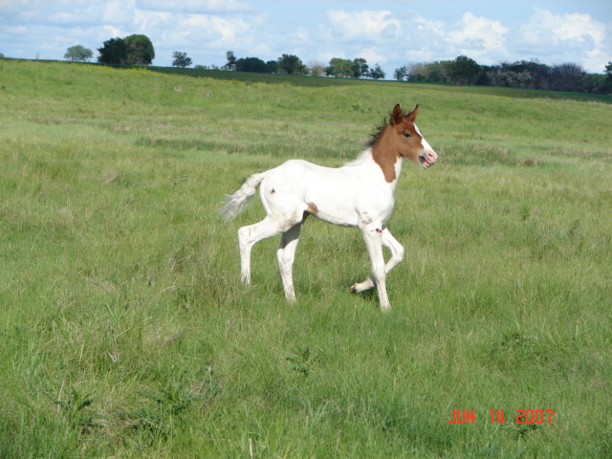
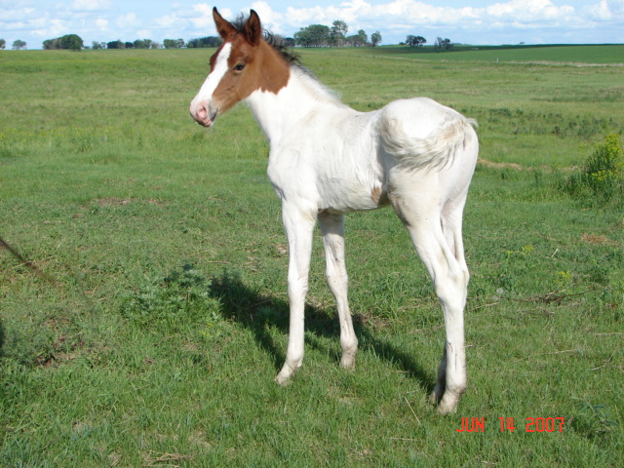
(Dos Lunas) Colt, PFHA# - 50,587
Vey well Gaited
DOB: May 30, 2007

website www.jonilund.com
Marichal Bolero LaCe by Volare/ Morena Bandolero Royal_ # 68922 Black Sofia La Negra by Dulce Suneo/ Sofia Alazana
# 1,327 Black, Endora Nino by ? Dulce Sueno
Pegasus Estaban____ # 68971 Black, Col Sierva ?
PFHA # 8,802 Pino Don Miguel Estaban Boricua by Batalla/ Nevada Cosa Differente Estaban # 69849 Roan Ilusion Godreau by Guamani by Dulce Sueno
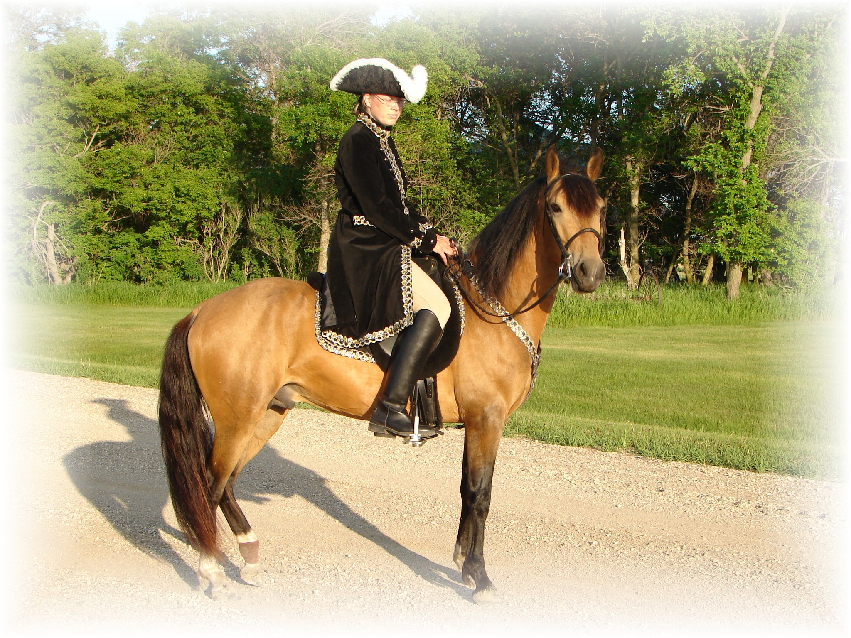
# 1,922; #70744 Pinto Fudia Estaban Danza by Guayama/ Espada
Monteado dePegasusPisadas # 70741 Bay pinto Rosita by Magia Blanca/ Princesa
# 23,618; #91529 Red/Bay tobiano Bolero LaCE Volare by Pincel/Princesa Mora
Campesino La CE # 68824 balck Morena by Gringo/Marianela # 1988 #70810 Bay; PR Dalfia LaCE Muneco LaCE by Lucifer/ La Polvora
Norelle de Encato #68870 gray Dalia LaCe by Gaucho/ La Dalia
#9359 #78181 Bay unknown unknown
Gitana Rosa unknown
SIRE # 2998 #71820 pinto unknown unknown
Future of Pisadas de Oro unknown
PFHA# 44,422 Sonador Ese Si by Guamani / Negra
- APLHA# 8603 Sizcocho LaCE #102096 PR#310 Enriqueta by Copa/ Dona Yin
- Golden Buckskin #512 #69334 Bay Maravilla LaCE Guamani by Dulce Sueno/Cordondillo Alazana
Tesoro Salago 102124 La Doctora by Dulce Sueno/Cordondillo Alazana
#519 #69341 Sombre LaCe Cori by Marinero/ Santa Elena
Buckskin (PR) Lunina LaCE #102152 Palomino Maria Luisa by El Huerlano/ La Crema
Alegria Salago #507 #69329, PR Carina LaCE Rojo by unknown
- #10133 #78955 ¾ PR/ ¼ col #68887 Vieja by unknown sire/ dam
Buckskin Very intelligent Muneco LaCE Lucifer El Cacque by unknown sire / dam
- #3 #68825 Gray #102031 (Col.) La Melva by unknown sire / dam Gwenona LaCE La Polvora Resorte I by Jupiter
- #517 #69339 #102032 (Col.) La Ninfa by unknown sire/ dam Bay? Brown Monona LaCE Furioso (aka Fury) Noche Buena by Dulce Sueno/Estrella
- ½ PR/ ½ col #510 #69332 #102075 (PR) Violeta by Dulce Sueno/ Felipa Bay PurePR Cocoa II Altanero by Caramelo#102033/ ? #102798 Cocoa by Unknown sire/ dam
Pegasus Estaban____ Bandolero Royal_ by Marichal / Endora PFHA # 8,802 B. Pino Cosa Differente Estaban by Don Miguel Estaban
Ultra Estaban La Caprichosa de Garbo Garbo que tal by Hilachas / Sombra
Concho del Prairie_ # 83759 # 73378 Gitana de Viz Caya by El Capricho/ La Cacela de viz-Caya
#87503 Don Cunda Marichal by Bolero LaCE/ Sofia LaNegra
#69119 Yoconda by Resorte Jr. / Catire
Lakehart Cidita Cafila que tal Sin Verguenza by El Zar/ La Sombra
# 75276 # 69129 Balonada by ?
GR Chico Magnifico Tierrel Elegante Precipitado Sin Par by El Paster/ Marisol Sin Par
# 93593 Black Tobiano # 78842 Channi La Perla by El Fuerte/ La Niebla
Gloriosa Pintada Danza Patero Estaban by Magia Blanca/Issusion Godreau
Don Domino Elegante de Tejas # 74956 Sabado Santo L by Miliciano Z/Coca de Borrascoso # 110695 Valido LaCE Mar de Plata LaCE by Vinol/ La Urbana
Molly Abel Frazier # 70505 Val de Osta LaCE by Bolero LaCE/ Mercedita LaCE
# 86965 Maritona con vivo Marichal by Bolero LaCE/Sofia La Negra
DAM Princessa de Cancion # 72834 Rintona by Faeton LaCE/ Rincon
Angelica Guarda de HG # 77027
PFHA# 115,969 Pistolero Cabullero by Caballo Viejo/ Marinera
Black Tobiano Pinto 14.2hh Contrapunto # 104410 Pistola by El Plata / La Paloma
- #104746 La Ligia Marino by Sogamoso/ Tunja
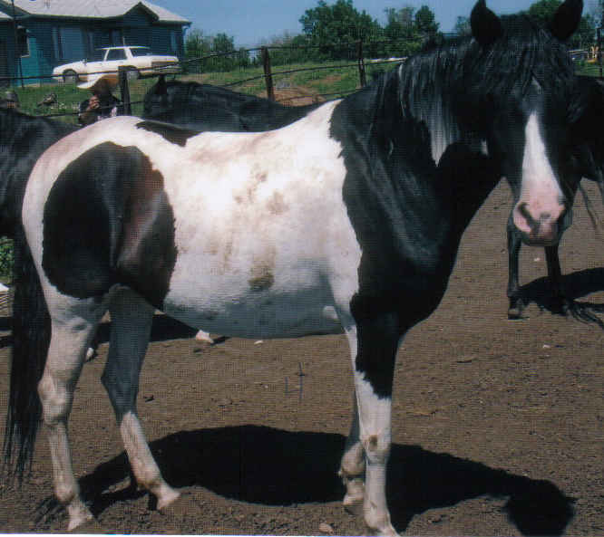
Gaytero # 104743 La Ligia I by Cantinflas / La Lira
# 79352 Resorte III Resorte II by Centauro (Viejo) / Jardinera
La Gayta # 72265 Guala by Plumaje / Celosa
# 106286 Serenata Carnaval by unknown
Primavera del Sultan # 106285 Chiquita by Dos de Mayo / Relampago
# 84458 Black 4 white socks Desvelo Gaucho by Jasmin/ La Campana
Plumaje # 102044 Cabinera by Cometa/ Flota
- #69728 La Mancha Embrujo by unknown
- Barbara del Borinquen # 102716 Retreta by unknown #70511 unknown ?
Bonita # ?
# 69877 unknown ?
# ?

Joni Lund – Equine Services, 1295 1st ST S, Carrington, ND 58421 (701) 652-1986

