For Sale or contract for foal.
JonisSophieConPrecisoPaso
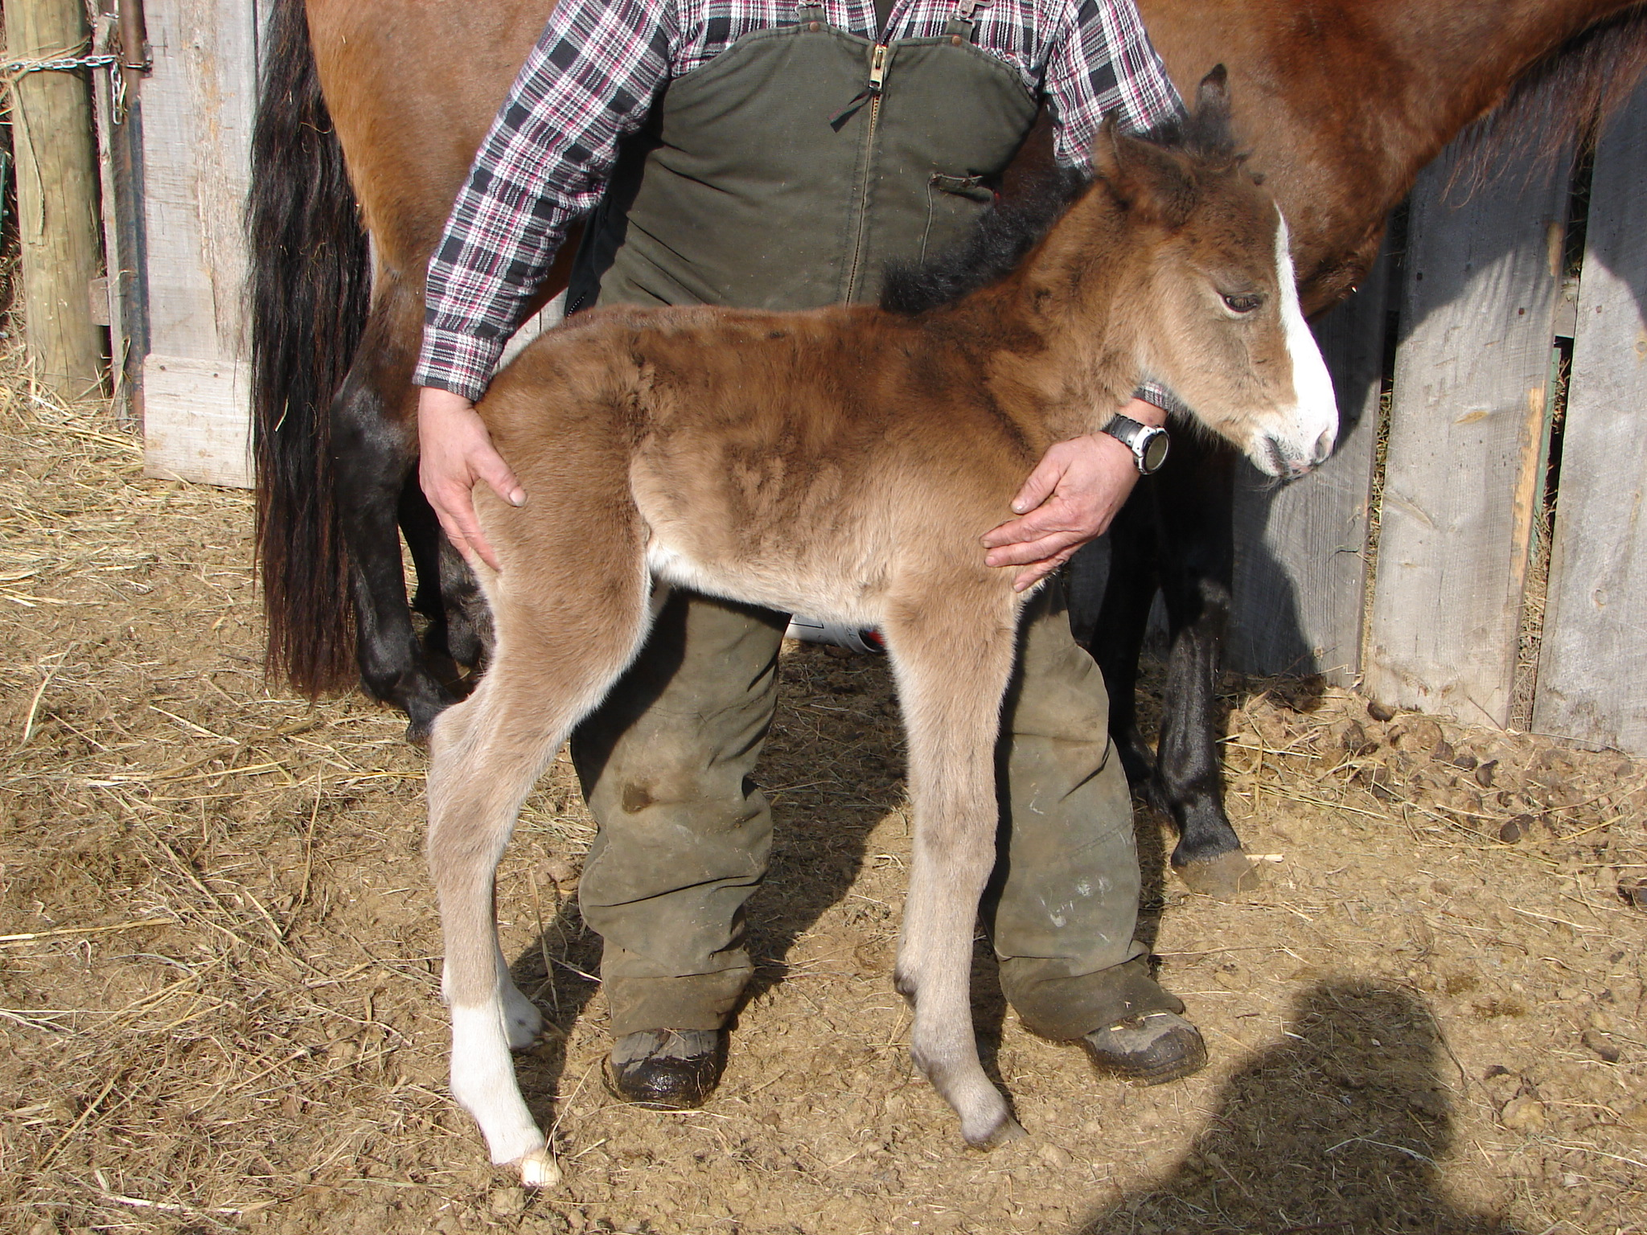
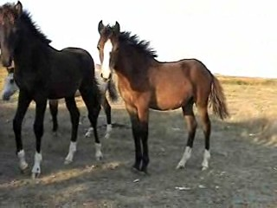
Paso Dam, PFHA# - 49,697
DOB: March 26, 2006
Website www.jonilund.com

Marichal Bolero LaCe by Volare/ Morena Bandolero Royal_ # 68922 Black Sofia La Negra by Dulce Suneo/ Sofia Alazana
# 1,327 Black, Endora Nino by ? Dulce Sueno
Pegasus Estaban____ # 68971 Black, Col Sierva ?
PFHA # 8,802 Pino Don Miguel Estaban Boricua by Batalla/ Nevada Cosa Differente Estaban # 69849 Roan Ilusion Godreau by Guamani by Dulce Sueno
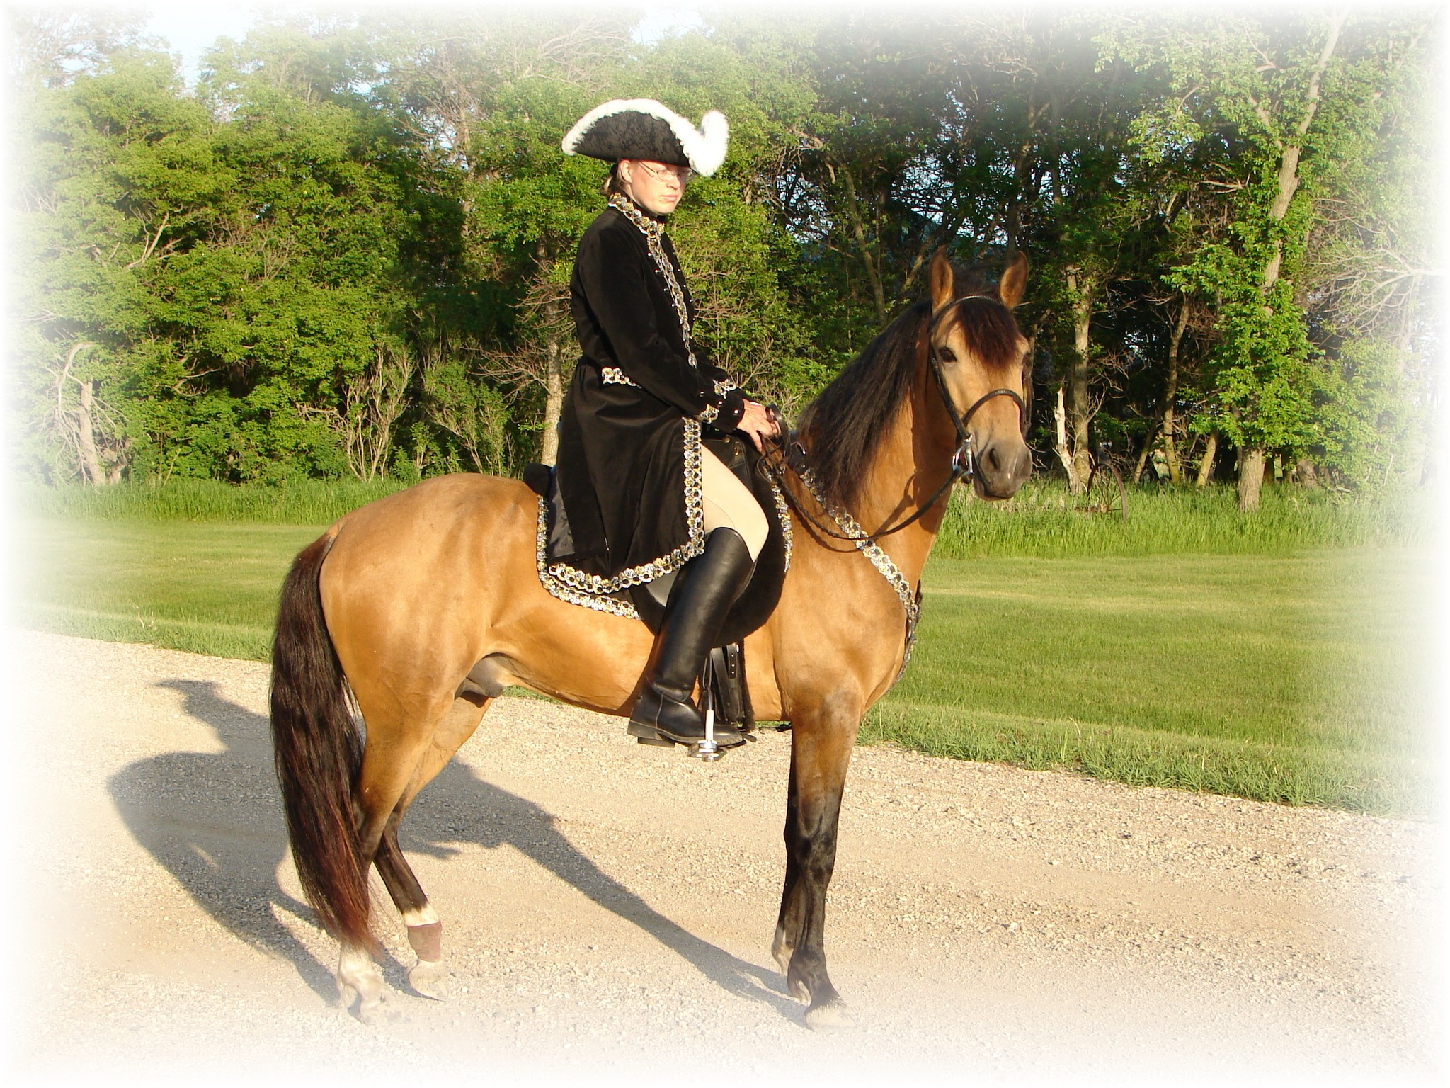
# 1,922; #70744 Pinto Fudia Estaban Danza by Guayama/ Espada
Monteado dePegasusPisadas # 70741 Bay pinto Rosita by Magia Blanca/ Princesa
# 23,618; #91529 Red/Bay tobiano Bolero LaCE Volare by Pincel/Princesa Mora
Campesino La CE # 68824 balck Morena by Gringo/Marianela # 1988 #70810 Bay; PR Dalfia LaCE Muneco LaCE by Lucifer/ La Polvora
Norelle de Encato #68870 gray Dalia LaCe by Gaucho/ La Dalia
#9359 #78181 Bay unknown unknown
Gitana Rosa unknown
SIRE # 2998 #71820 pinto unknown unknown
Future of Pisadas de Oro unknown
PFHA# 44,422 Sonador Ese Si by Guamani / Negra
- APLHA# 8603 Sizcocho LaCE #102096 PR#310 Enriqueta by Copa/ Dona Yin
- Buckskin #512 #69334 Bay Maravilla LaCE Guamani by DulceSueno/Cordondillo Alazana
Tesoro Salago 102124 La Doctora by Dulce Sueno/Cordondillo Alazana
#519 #69341 Sombre LaCe Cori by Marinero/ Santa Elena
Buckskin (PR) Lunina LaCE #102152 Palomino Maria Luisa by El Huerlano/ La Crema
Alegria Salago #507 #69329, PR Carina LaCE Rojo by unknown
- #10133 #78955 ¾ PR/ ¼ col #68887 Vieja by unknown sire/ dam
Buckskin Very intelligent Muneco LaCE Lucifer El Cacque by unknown sire / dam
- #3 #68825 Gray #102031 (Col.) La Melva by unknown sire / dam Gwenona LaCE La Polvora Resorte I by Jupiter
- #517 #69339 #102032 (Col.) La Ninfa by unknown sire/ dam Bay? Brown Monona LaCE Furioso (aka Fury) Noche Buena by Dulce Sueno/Estrella
- ½ PR/ ½ col #510 #69332 #102075 (PR) Violeta by Dulce Sueno/ Felipa Bay PurePR excellent gait line Cocoa II Altanero by Caramelo#102033/ ? #102798 Cocoa by Unknown sire/ dam
Capuchino Resorte Quarto Resorte III Resorte II / Guala
# 6,944 Chestnut # 76172 Cascanueces Mirasol/ La Colorao
#75766, Col. Fino Capuchina II Resorte Quarto Resorte III/ Cascanueces
El Picaflor de Casta # 105204 Capuchina II Anfitrion/ Capuchina I
PFHA #12,824 Ladrillo Guazipungo Plumaje/ Venenosa Chestnut Leyenda La Joya # 75215 Mireya Sultan/ ? #6,395 Chestnut Sotileza Ponce Guamani/ Carioca
# 82009 Piel de Seda Copita/ Espiritista Fantasma de Casta Gracioso Bochica Guazipungo Plumaje/ Gitana PFHA # 31,926 # 7,512 Bay # 104175 La Diana Abolengo / ?
# 99803 Black La Vendetta de Casta Zamarcanda II Resorte III Resorte II/ Guala
PFHA # 23,321 Bay #.105546 Zamarcanda I Caballo Viejo/ La Pisaflores Capuchino Resorte Quarto Resorte III/ Cascanueces
La Malaguena de Casta # 75766 chestnut Capuchina III Resorte III/ Capuchina II DAM # 12,823; 81645 Chestnut Marichuela Resorte Quarto Resorte III/ Cascanueces
La Joy de HG # 75088 La Estirpe I Caballo Viejo/ Estirpe Vieja

BAY, PFHA# 42,846 Marichal Bolero LaCe Volare/ Morena
Bandolero Royal___ # 68922 Black Sofia La Negra Dulce Suneo/ Sofia Alazana
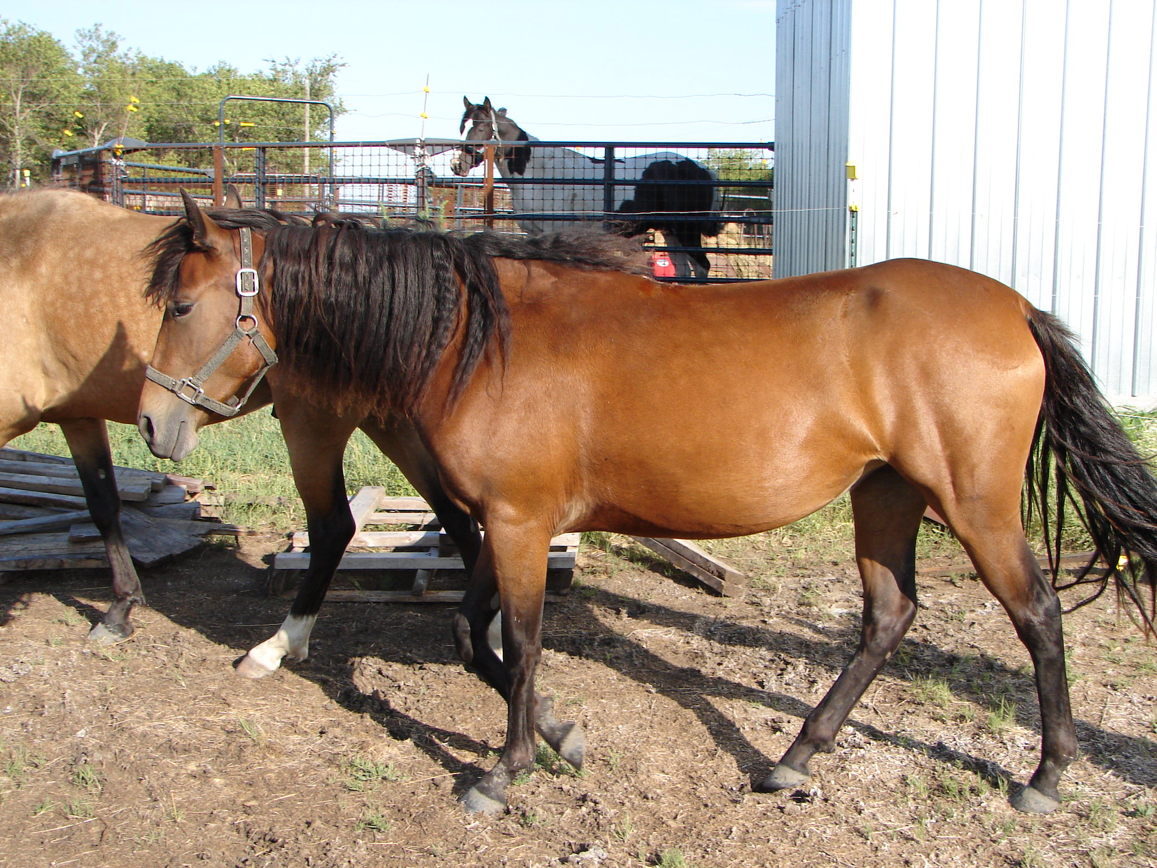
# 1,327 Black Endora Nino ? Dulce Sueno/ ? Pegasus Estaban____ # 68971 Black, Col. Sierva ? / ?
PFHA # 8,802 Pint,o L Don Miguel Estaban Boricua Batalla/ Nevada
Cosa Differente Estaban # 69849 Roan, Ilusion Godreau Guamani/ La Greco
#1,922 Pinto Fudia Estaban Danza Guayama/ Espada
Esperanza de Irlanda # 70741 Bay pinto Rosita Magia Blanca/ Princesa
PFHA # 21,564 Bay Dablado Sombra Hombre Genty/ Fudia Estaban Estaban’s Diablo # 70909 Big Pinto Careta Princesa El Checha / Baya
# 4,209 Black Pinto Cosa differente Estaban Don Miguel Estaban Boricua./ Ilusion Godreau Conchata Estaban__ only other ½ brother of Pegasus # 70744 pinto Fudia Estaban Danza/ Rosita
PFHA # 6,299 pinto Favorito que tal Baron que tal Eblis/ Maria Bonita Corto, very good Komashor Athena # 70730 Bay, Col., Sombra ? / Sanforizada
Largo breeding in # 3,928 Bay 50%PR50%Col Minerva de Faeton CJ Faeton LaCE Guamani / ?
the 60’s in pinto color # palomino Mia Suena Canario/ Redonda

Joni Lund – Equine Services 1295 1st ST S, Carrington, ND 58421 (701) 652-1986

