At Stud or For sale at the right price.
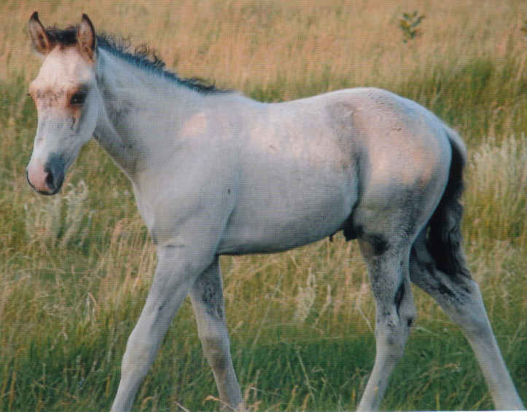
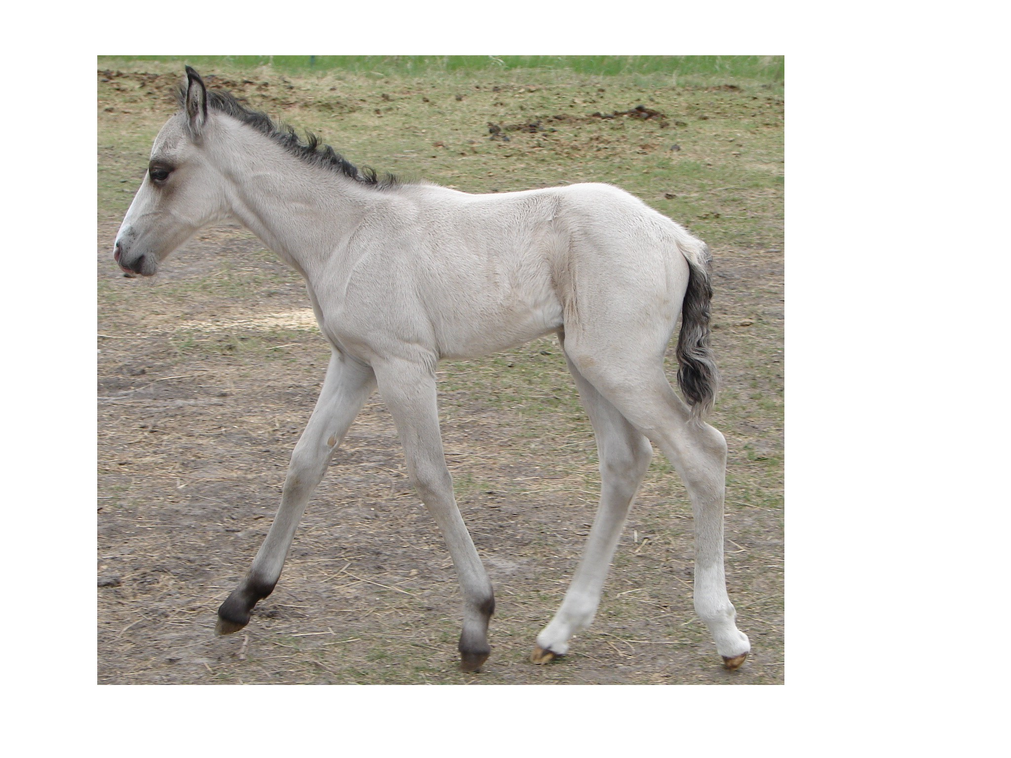
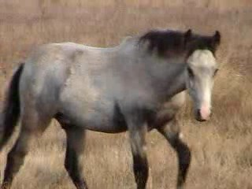
Joni’s Chief Eagle Feather
Colt, PFHA# - 49,696
Paso buttermilk buckskin, NO GREY GENE.
Born: May 17, 2006

Website www.jonilund.com

Marichal Bolero LaCe by Volare/ Morena Bandolero Royal_ # 68922 Black Sofia La Negra by Dulce Suneo/ Sofia Alazana
# 1,327 Black, Endora Nino by ? Dulce Sueno
Pegasus Estaban____ # 68971 Black, Col Sierva ?
PFHA # 8,802 Pino Don Miguel Estaban Boricua by Batalla/ Nevada Cosa Differente Estaban # 69849 Roan Ilusion Godreau by Guamani by Dulce Sueno
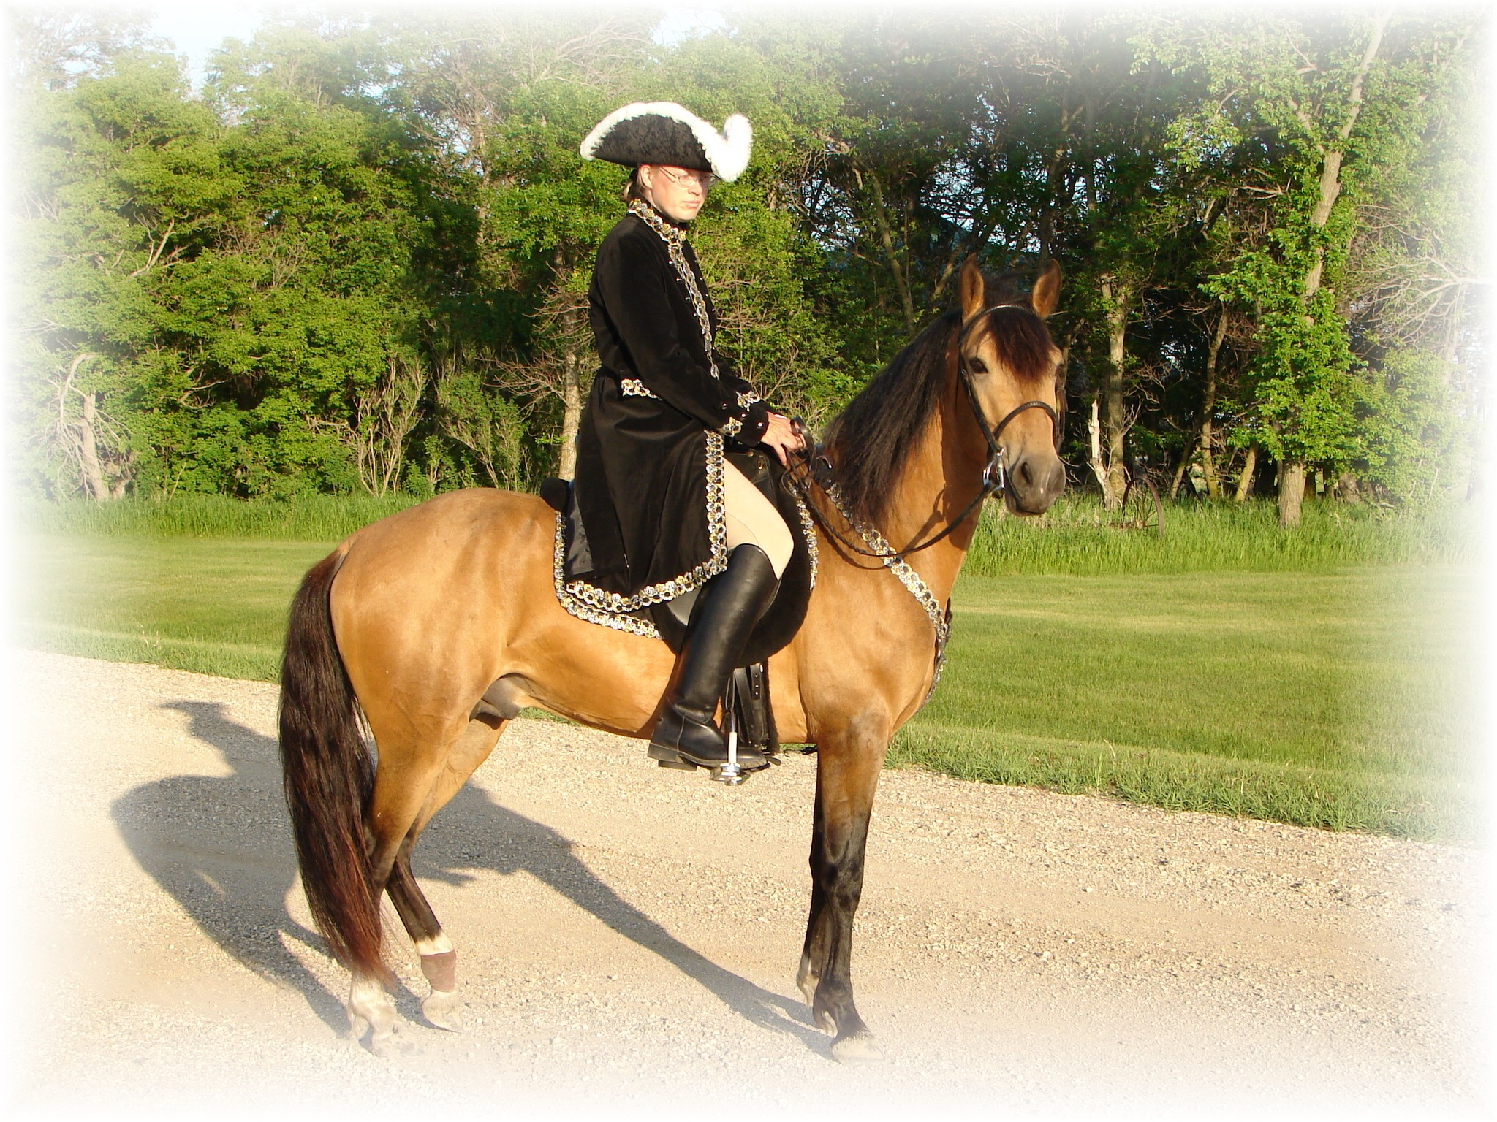
# 1,922; #70744 Pinto Fudia Estaban Danza by Guayama/ Espada
Monteado dePegasusPisadas # 70741 Bay pinto Rosita by Magia Blanca/ Princesa
# 23,618; #91529 Red/Bay tobiano Bolero LaCE Volare by Pincel/Princesa Mora
Campesino La CE # 68824 balck Morena by Gringo/Marianela # 1988 #70810 Bay; PR Dalfia LaCE Muneco LaCE by Lucifer/ La Polvora
Norelle de Encato #68870 gray Dalia LaCe by Gaucho/ La Dalia
#9359 #78181 Bay unknown unknown
Gitana Rosa unknown
SIRE # 2998 #71820 pinto unknown unknown
Future of Pisadas de Oro unknown
PFHA# 44,422 Sonador Ese Si by Guamani / Negra
- APLHA# 8603 Sizcocho LaCE #102096 PR#310 Enriqueta by Copa/ Dona Yin
- #HOA 1489 #512 #69334 Bay Maravilla LaCE Guamani by Dulce Sueno/Cordondillo Alazana
#NAM 05650 Tesoro Salago 102124 La Doctora by Dulce Sueno/Cordondillo Alazana
Buckskin #519 #69341 Sombre LaCe Cori by Marinero/ Santa Elena
Buckskin (PR) Lunina LaCE #102152 Palomino Maria Luisa by El Huerlano/ La Crema
Alegria Salago #507 #69329, PR Carina LaCE Rojo by unknown
- #10133 #78955 ¾ PR/ ¼ col #68887 Vieja by unknown sire/ dam
Buckskin Very intelligent Muneco LaCE Lucifer El Cacque by unknown sire / dam
- #3 #68825 Gray #102031 (Col.) La Melva by unknown sire / dam Gwenona LaCE La Polvora Resorte I by Jupiter
- #517 #69339 #102032 (Col.) La Ninfa by unknown sire/ dam Bay? Brown Monona LaCE Furioso (aka Fury) Noche Buena by Dulce Sueno/Estrella
- ½ PR/ ½ col #510 #69332 #102075 (PR) Violeta by Dulce Sueno/ Felipa Bay PurePR excellent gait line Cocoa II Altanero by Caramelo#102033/ ? #102798 Cocoa by Unknown sire/ dam
*Bolero LaCE Volare by Pincel/Princesa Mora
Marichal 68824 Morena by Gringo/ Marianela
100 Black Sofia La Negra Dulce Sueno by Caramelo/ Mosqueda
Bandolero Royal 102039 Sofia Alazana by Patiblanco/ Cordoncillo Zaina
1,327 Black Endora Nino Dulce Sueno by Caramelo/ Mosqueda
149 Black 102090 unknown
68971 Sierva unkown
Pegasus Estaban 102408 unkown
8,802 Black Pinto Boricua Batalla by Dulce Sueno/ Felipa
Don Miguel Estaban 102881 Neveda by Patiblanco
1,027 Roan 69849 Ilusion Godreau Guamani by Dulce Sueno/Cordondillo Alazana
Cosa Differente Estaban 103164 La Greco by Guamani/ Ilusion
1,922 Buckskin Pinto 70744 Danza Guayama by Guamani / ?
DAM Fudia Estaban 103368 Espada by Cacique/ Espadita
Esperanza de Irlanda 1,919 Bay Pinto Rosita Magia Blancia by Guayama/ La Loca
PFHA# 21,564 70741 103369 Princesa ? Dablado Sombre Hombre Genty ?
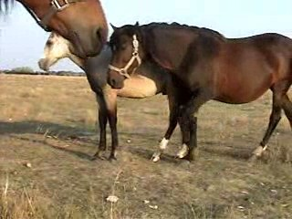
2,087 Pinto 70909 70836 pinto Fudia Estaban by Danza/ Rosita
Estaban’s Diablo Careta Princesa El Checha ?
3,928 Black pinto 70835 Baya by Sorpresa/ Zaina
Don Miguel Estaban Boricua by Batalla/Nevada
Cosa Differente Estaban 69849 Ilusion Godreau by Guamani/ La Greco
Conchata Estaban 1,922 Pinto 70744 Fudia Estaban Danza by Guayama/ Espada
6,299 Pinto 70741 Rosita by Magia Blanca/ Princesa
Very good pinto largo Baron que tal Eblis ?
Breeding for 60s & 70’s Favorito Que tal 69127 Maria Bonita by Eblis/ Diana
Komashor Athena 1,908 Bay 70730 Sombra unknown ?
3,928 Bay 68979 Sanforizada ?
50%Col.50%PR Faeton LaCE Guamani by Dulce Sueno/ Cordoncillo Alazana
Mininerva de Faeton CJ 68877 PR unknown ?
1,648 Palomino Mia Suena Canario by Palomo/ Calabaza
68878 Redonda ?
Joni Lund – Equine Services 1295 1st ST S, Carrington, ND 58421 (701) 652-1986

