Da Vinci
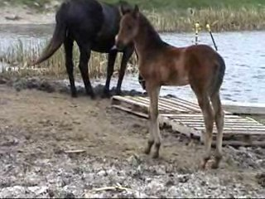
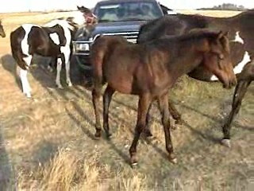
Solid Bay Colt, Born: April 18, 2006
American Paint Horse Assoc. # 859,759
North Dakota Racing Commission # 3130

Blood lines go back to Man O‘War on both sire & dam’s side.

1 month 3 months

Bred for Barrel, Roping, Ranch, Gaming, Halter, ?-Track.
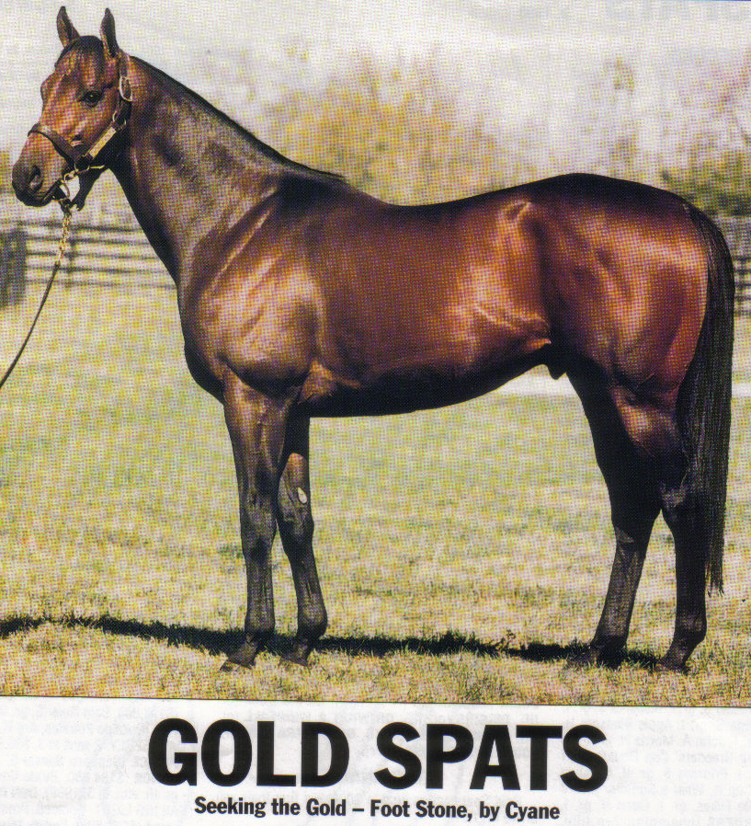
^Sire Sire Dam
Mr. Prospector, 1970 →  Raise A Native, 1961 → Native Dancer 1950→Polynesian 1942 & Geisha 1943
/ DI=3.95, 4.35 AEI $45,955, 2.36 AEI →Raise You, 1946 →Case Ace, 1934 & Lady Glory 1934 [Producing the majority of ] Gold Digger, 1962 →Nashua , 1952 →*Nasrullah, 1940 & Segula 42
Seeking The Gold [Top winning TBs in USA ]→ JC# $127,255 →Sequence, 1946 DI=3.18 →Count Fleet 40 & Miss Dogwood 39 by *Bull Dog
JC# b,1985 16hh
[P Producing the majority of] \
[Ttop winning TBs in USA.] Con Game, 1974 → Buckpasser, 1963 →Tom Fool, 1949 →Menow 35 by Pharamond II 1925/Alcibiades 27 & Gaga by*Bull Dog
[15 S,SW,$2,307,000,288 f,] JC# DI=1.32 $1,462,014 3.92 AEI →Busanda, 1947 →War Admiral By Man O'War/Brushup & Businesslike
[29SW,3.03 AEI, DI=3.15] →Broadway, 1959 → Hasty Road DI=1.26 →Roman by *Sir Gallahad III /*Buckup & Traffic Court
Gold Spats (TB) JC# $44,583 →Flitabout →Challedon by*Challenger II & Bird Flower
JC #9314777 Dk. Bay
A multi allowance winning miler Cyane 1959 → TURN-to 1951 →Royal Charger →Nearco &
In England/France. $54,133 / $159,367 2.34AEI 2.86 AEI →Source Sucree →Admiral Drake &
SIRE Foot Stone → Your Game 1948 →Beau Pere → Son-in-Law &
JC # dkb/br,1983 →Winkle II →Windsor Lad &
$119,300. \
29s, SW,8f, 7R, 4W,1 SW Hecate 1977 → Ack Ack 1966 →Battle Joined →Armageddon &
$10,020 2.35 AEI →FAST TURN →TURN-to &
→ Witching Hour 1960 →Thinking →Rosemont &
→Enchanted Eve →Lovely Night &
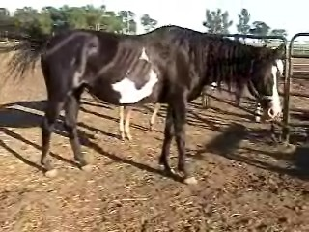
YETAHEY → Streakin Dash →Streakin Six (QH) →Easy Six by Easy Jet by Jet Deck & Miss Assured
/ 293,696 -- QH#1997643 →GOT A LOT GOING (QH)→Dash For Cash by Rocket Wrangler & GOTTA GO TOO
YETA TIS → Lady Bird Too →EASY JET TOO →Easy Jet , Si 100 by Jet Deck & Indian Music
APHA# 485,453 # 120,030 Bay Tobiano →Easy Lady Bug → Lady Bugs Moon by Top Moon & Easy Bird
\
TIS REGAL → National Flag (TB) →Flag Raiser (TB) →Rough ‘n Tumble FromRoused & Larks War by War Relic
(JC) 9,127,235 Bay -- T0033963 →Princess East (TB) →? &
→ TIS A TOMBOY →Rick (TB) →Royal Coinage & Rytina
Sweet Honey Ace JC # (TB) →Gay Gungga-tot (TB) → ? &
American Paint Horse Assoc#753,3177
DAM MR GLAMMER BOY→ Mr. Sixteen →Aces Tuffy Too →IMA TUFFY TOO & Ace Candy Deep
# 149,110 -- #97,033 Bay Overo →Ms Sweet Sixteen (QH) →Bruce’s Dream Bar & Shammy's Sixteen
/ Brown overo → Honey Angie →Honey Bar Chick (QH) →Three Chicks & Miss Tidy
TOMMYS GLAMMER GAL QH# 1,419,187 →Tough Angie (QH) →Tough Time & Moonlight Lady
APHA# 308,952 \
Bay Overo TOMMYS HEADLIGHT → Mr. Sixteen →Aces Tuffy Too → IMA TUFFY TOO & Ace Candy Deep
196,289 -- #97,033 Bay Overo →Ms Sweet Sixteen (QH) → Bruce’s Dream Bar & Shammy's Sixteen
Bay Overo → Kennys Girl → Double Doc Horn (QH) → Croton Oil & Sugaree Bars
QH# 1,687,115 →Dakota Play Girl (QH)→Blackburn Ladie & Beauty Play

Best to Write Joni Lund – Equine Services, or Phone: (701) 652-1986
Manager Rafter J Bar
1295 1st St S
Carrington, ND 58421

email jonisstallionservice@yahoo.com Web site: www.jonilund.com

