For Sale or contract for foal.
Bayberry Lady JL
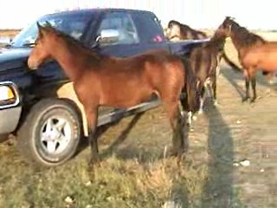
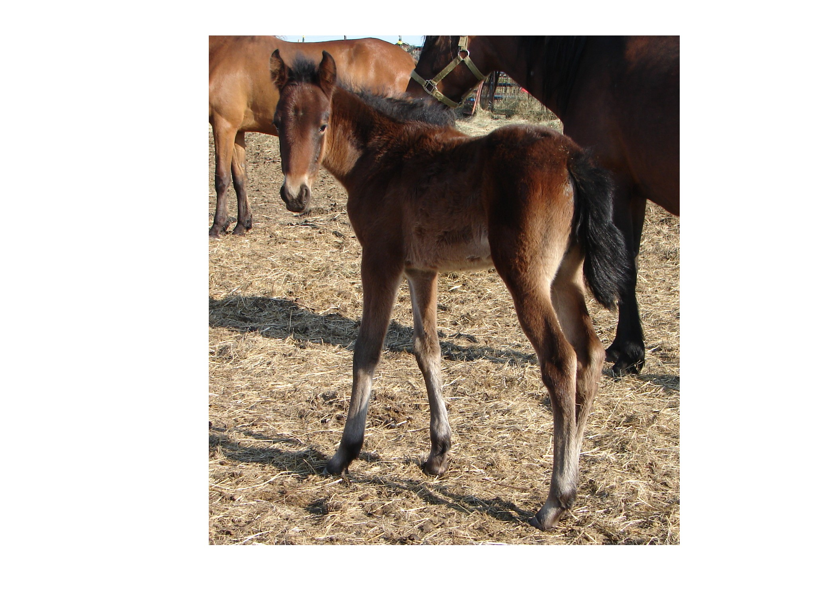
PFHA # 49,698 Solid Bay Mare
14.2-15hh, Born: April 23, 2006

website www.jonilund.com

Marichal Bolero LaCe by Volare/ Morena Bandolero Royal_ # 68922 Black Sofia La Negra by Dulce Suneo/ Sofia Alazana
# 1,327 Black, Endora Nino by ? Dulce Sueno
Pegasus Estaban____ # 68971 Black, Col Sierva ?
PFHA # 8,802 Pino Don Miguel Estaban Boricua by Batalla/ Nevada Cosa Differente Estaban # 69849 Roan Ilusion Godreau by Guamani by Dulce Sueno
# 1,922; #70744 Pinto Fudia Estaban Danza by Guayama/ Espada
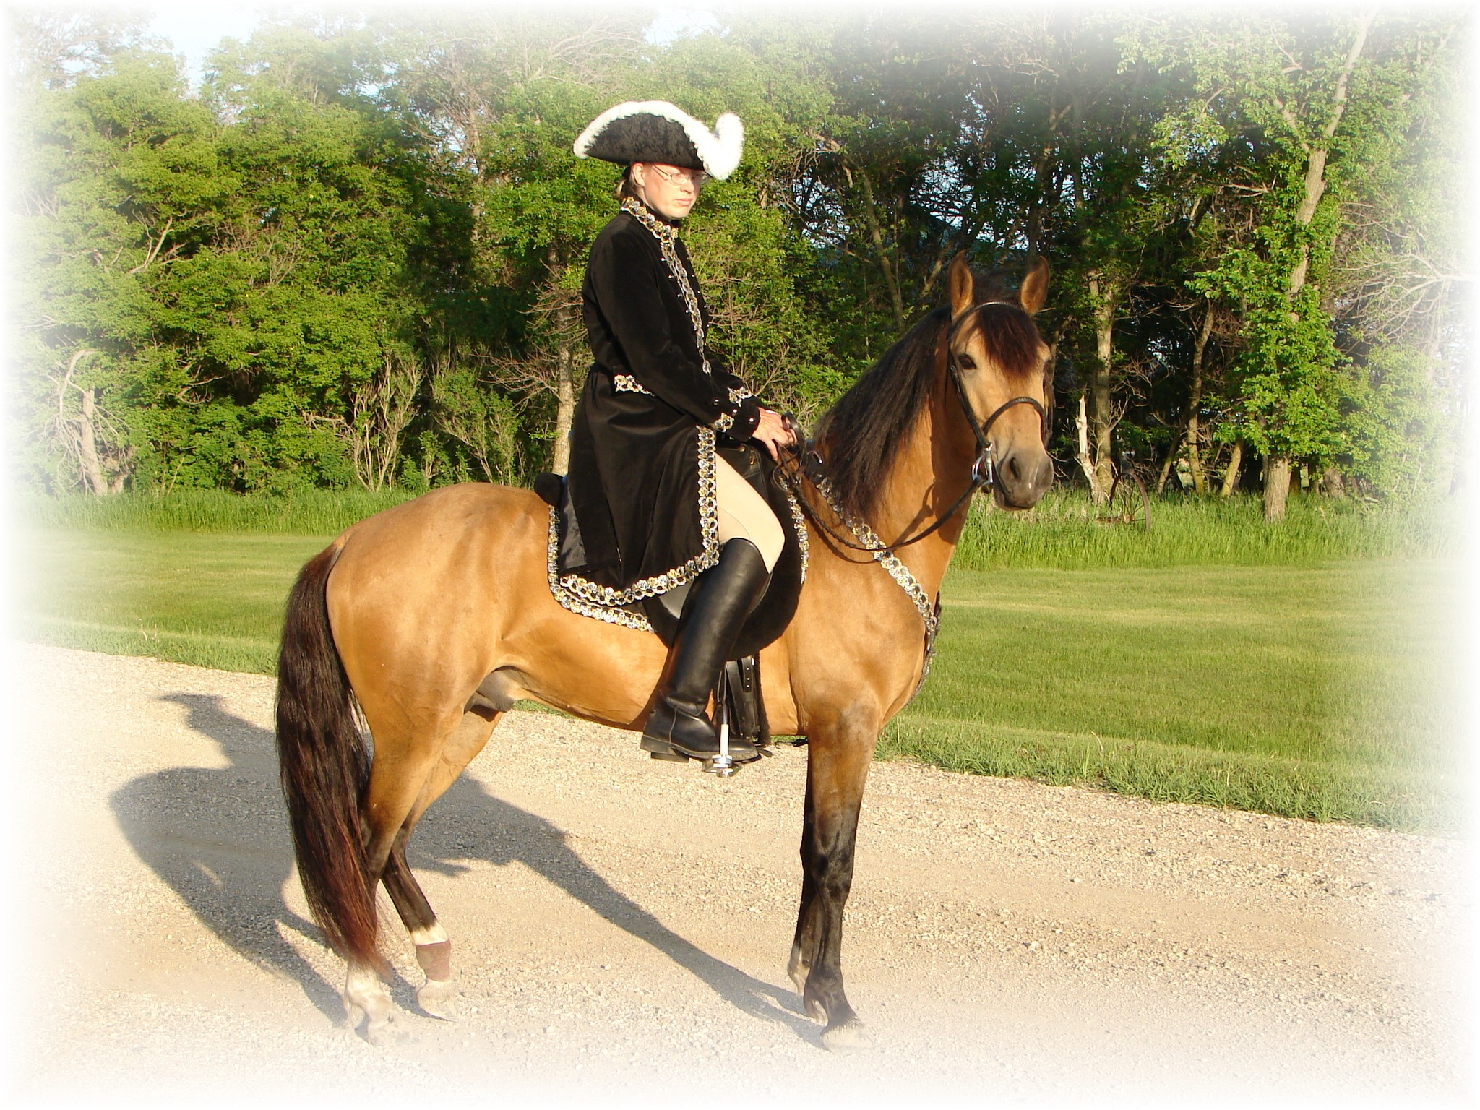
Monteado dePegasusPisadas # 70741 Bay pinto Rosita by Magia Blanca/ Princesa
# 23,618; #91529 Red/Bay tobiano Bolero LaCE Volare by Pincel/Princesa Mora
Campesino La CE # 68824 balck Morena by Gringo/Marianela # 1988 #70810 Bay; PR Dalfia LaCE Muneco LaCE by Lucifer/ La Polvora
Norelle de Encato #68870 gray Dalia LaCe by Gaucho/ La Dalia
#9359 #78181 Bay unknown unknown
Gitana Rosa unknown
SIRE # 2998 #71820 pinto unknown unknown
Future of Pisadas de Oro unknown
PFHA# 44,422 Sonador Ese Si by Guamani / Negra
- APLHA# 8603 Sizcocho LaCE #102096 PR#310 Enriqueta by Copa/ Dona Yin
- #HOA 1489 #512 #69334 Bay Maravilla LaCE Guamani by Dulce Sueno/Cordondillo Alazana
#NAM 05650 Tesoro Salago 102124 La Doctora by Dulce Sueno/Cordondillo Alazana
Buckskin #519 #69341 Sombre LaCe Cori by Marinero/ Santa Elena
Buckskin (PR) Lunina LaCE #102152 Palomino Maria Luisa by El Huerlano/ La Crema
Alegria Salago #507 #69329, PR Carina LaCE Rojo by unknown
- #10133 #78955 ¾ PR/ ¼ col #68887 Vieja by unknown sire/ dam
Buckskin Very intelligent Muneco LaCE Lucifer El Cacque by unknown sire / dam
- #3 #68825 Gray #102031 (Col.) La Melva by unknown sire / dam Gwenona LaCE La Polvora Resorte I by Jupiter
- #517 #69339 #102032 (Col.) La Ninfa by unknown sire/ dam Bay? Brown Monona LaCE Furioso (aka Fury) Noche Buena by Dulce Sueno/Estrella
- ½ PR/ ½ col #510 #69332 #102075 (PR) Violeta by Dulce Sueno/ Felipa Bay PurePR Cocoa II Altanero by Caramelo#102033/ ? F #102798 Cocoa by Unknown sire/ dam
Ministro Resorte Quarto Resorte III by Resorte II/ Guala
Camelio_ # 6,267 Bay # 76172 Cascanueces by Mirasol/ La Colorada
# 7,689 Bay La Buguena Chucuano by ?
# 104859 La Milonga by Monarca / Monedera
La Repique Marengo II Marengo by Resorte III/ La Bogotana # 7,057 Gray # 105270 Cayetana by ResorteIII/ La Fundaora
Novicio de Las Casas La RepiqueI El Chulo I by Carnaval Viejo/ ?
# 20,924 Bay #88837 # 105271 La Repique by El Chulo/ La Sarita
Resorte III Resorte II by Centauro (Viejo)/ Jardinera
Sereno # 72265 Guala by Plumaje/ Celosa
#104783 Resolana Lucifer by Timochenco/ Gacela
Novicia # 105710 Sultana by Saleroso/ Sultana I
# 6,808 Bay Relicario Faquir ?
Reliquia # 105010 Marsellesa ?
DAM #105012 La Mona ?
Flying M Java # 105011 ?
PFHA# 26,089 Sin Verguenza El Zar by El Principe/ La Marquesa to Rey Cometa
Solid Bay 14.3hh Astro de Morisca # 102177 La Sombra by El Coral / La Gaviota
- #102188 Morisca El Robie by ? / ?
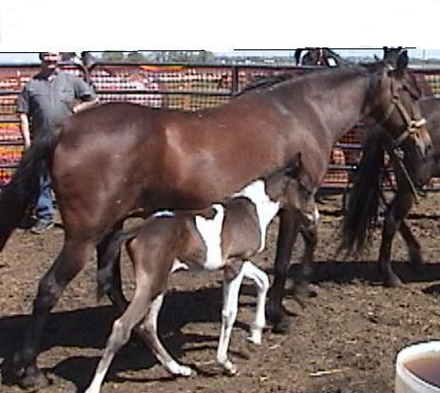
Bochica del Cardo # 102187 Mandarina by ? / ?
# 1,865 Bay Mahoma Triunfo by Andio /La Chispa
Capucha que tal # 102310 Mecita de Salagar by ? / ?
# 169Bay #68991 Venus Eblis by ? / ?
La Macarena donde es # 69498 Diana by ? / ? # 5,424 Bay Caruso Jupiter by Crespo by Rucito
Cirano # 103170 ?
- # 1,693 Gray Califa ?
- de Marca donde es # 103171 ? # 2,526 Dun #71348 G igante ?
Dona Viva # 103393 ?
# 2,172 Gray #70994 Dulce Castana ?
# 70968 ?

Joni Lund – Equine Services, Rafter J Bar, 1295 1st St S Carrington, ND 58421
(701) 652-1986
Equine Semen Collection & Shipping Service - Horses - Mules - Tack

