Future of Pisadas de Oro
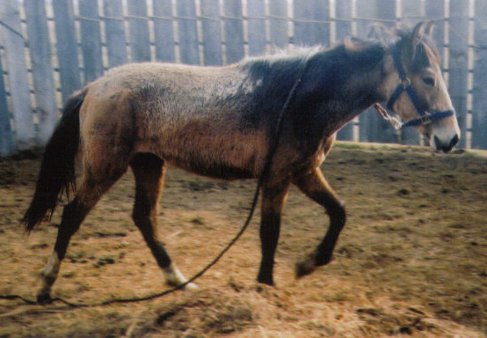
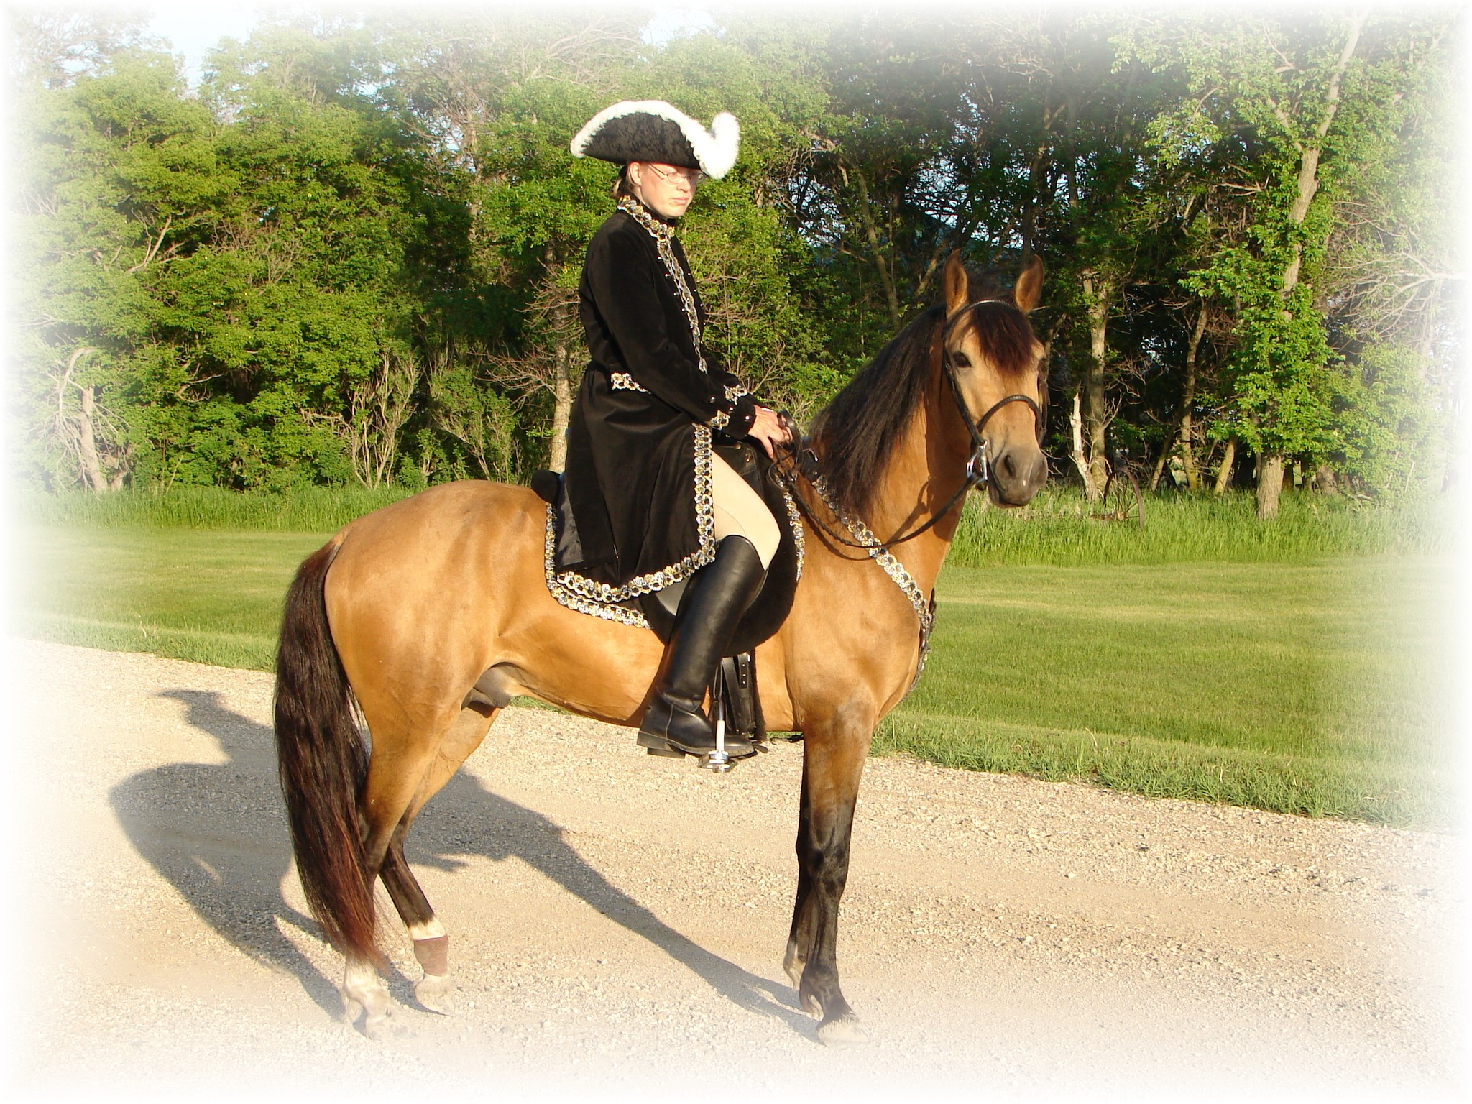
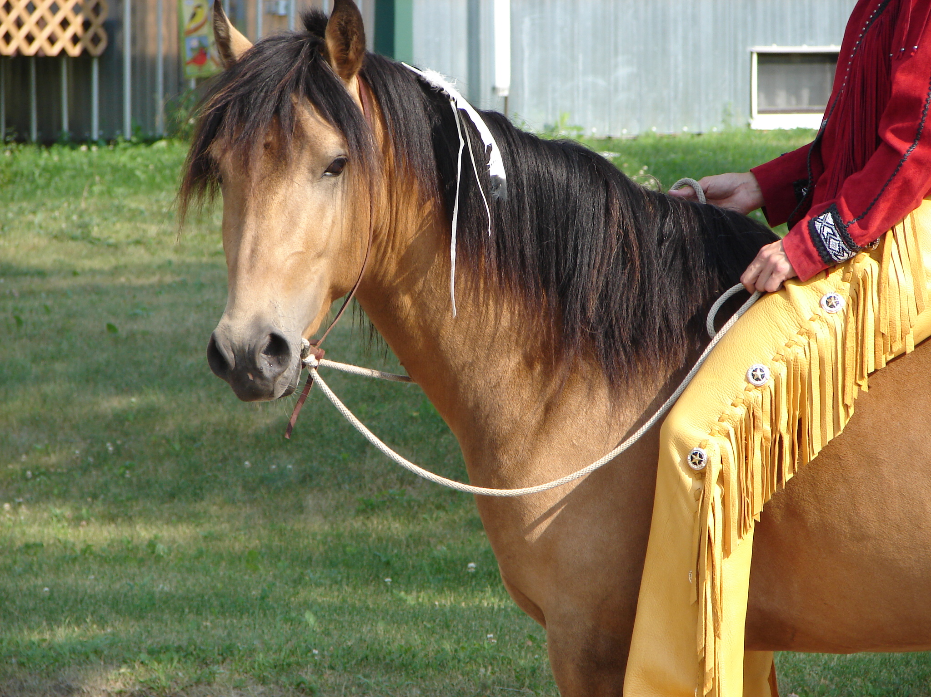
Golden Buckskin Paso At Stud
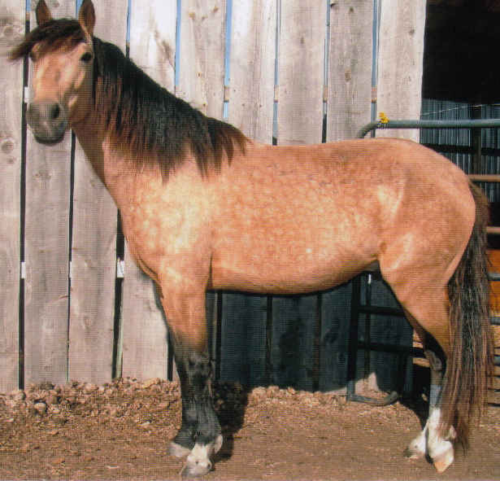
Born: 5/6/2003
Paso Fino Horse Assoc.# 44,422
American Paso Largo Horse Assoc.# 8603

Website www.jonilund.com
2006 rope bit, no tack 2006
- Bolero LaCE Volare #102025 by Pincel/Princesa Mora
- Sires Pedigree Marichal #68824 Morena #102026 by Gringo/Marianela
- #68922 black Sofia La Negra Dulce Sueno #102037 by Caramelo/Mosqueda
- Bandolero Royal #102039 Sofia Alazanca #102038 by Patiblanco/Cordoncillo Zaina
- #1327 #70149 Black Nino Dulce Sueno#102037 by Caramelo/Mosqueda
- Endora #0081 #102090 Unknown dam
- This column champions start #68971 #149 Black Sierva Unknown sire
- Pegasus Estaban #102408 Unknown dam
- #8802 #77624 Boricua Batalla #102059, by Dulce Sueno/Felipa
- Black Tobiano Don Miguel Estaban #102881 Neveda #102880, by Patiblanco/ ?
- 69849 Roan Ilusion Godreau Guamani #102050 by Dulce Suenco/ Cordoncillo Alazana
#103164 La Greco #103162, by Guamani/ Ilusion
Cosa Differente Estaban Danza Guayama #102252 by Guamani#102050/ ?
#1922 #70744 Pinto Fudia Estaban #103368 Espada #103367, by Cacique/ Espadita
- 70741 Pinto Rosita Magia Blanca #103163 by Guayama/La Loca
- Monteado dePegasusPisadas #103369 Princesa #102649 ? / ?
- #23,618 #91529 Volare Pincel #102021 by Copita (Don Q)/Santa Rita II
- Red/Bay Tobiano Bolero LaCE #102025 Princesa Mora#102018 by Pisaflores/La Rucia
- #8824 #68824black Morena Gringo #102023 by Princesita II/Princesa Mora
- Campesino LaCE foundation sire #102026 Marianela#102024, by Nina Esa/Vamonte #1988 #70810 Bay Muneco LaCe Lucifer #102031, by El Cacque/La Melva
- PR Dalfia LaCE #68825 La Polvora #102032, by Resorte I/La Ninfa
- Norelle de Encanto #68870 gray Dalia LaCE Gaucho #102040, by Jasmin/La Campana
- # 9359 #78181 #102201 La Dalia #102200 by Contrabando/ Campesina Bay Gitana Rosa unknown sire unknown sire
- # 2998 #71820 unknown dam
Tobiano Pinto unknown dam unknown sire
unknown dam
- This column champions start Ese Si Guamani #102050 PR#147 by Dulce Sueno/ Cordoncillo Alazana
- Sonador #102126 Negra #102333 ? / ?
- #102096 PR#310 Enriqueta Copa #104295 ? / ?
- Dams Pedigree Sizcocho LaCE Bay with Star #104294 Dona Yin #104296 ? / ?
- #512 #69334 Bay Guamani Dulce Sueno #102037 by Caramelo/Mosqueda
- Maravilla LaCE #102050 Cordondillo Alazana by Patiblanco/Cordoncillo Zaina
- Tesoro Salago 102124 La Doctora Dulce Sueno #102037 by Caramelo/Mosqueda #519 #69341 #102123 Cordondillo Alazana by Patiblanco/Cordoncillo Zaina
Buckskin PR FAST Line Cori Marinero #102099 by Dije/ Zafra
- Sombre LaCE #102151 Santa Elena #102695 by Dulce Sueno/ Cordondillo Alazana
- Lunina LaCE #102152 Palomino Maria Luisa El Huerlano #102259 by Faron I/ Paloma
- #507 #69329 #71247 Crème #2425 La Crema #102260 by Batalla/ Nevada by Dulce Sueno
- Buckskin Rojo unknown sire
- Carina LaCE #102214 unknown dam
- Alegria Salago #68887 Vieja unknown sire
- #10133 #78955 #102215 unknown dam
- Buckskin El Cacque unknown sire
- Very intelligent Lucifer #102027 unknown dam
- Muneco LaCE #102031 La Melva unknown sire
- #3 #68825 Gray #102028 unknown dam
- Resorte I Jupiter #111657 by Crespo #111494/ ?
- La Polvora #102004 Bay La Negra #112094
- Gwenona LaCE #102032 La Ninfa unknown sire
- #51771 #69339 #102030 unknown dam
- Bay? Brown Noche Buena Dulce Sueno #102037 by Caramelo/Mosqueda
- Furioso #102952 Estrella #102166 by Batalla/Consuelo by Dulce Sueno Monona LaCE (aka Fury) Violeta *Dulce Sueno #102037 by Caramelo/Mosqueda
- #510 #69332 #102075 #102074 Felipa #103398 ? / ?
- Bay Altanero Caramelo #102033 by Dulce Sueno / Curra
- Cocoa II #102797 Unknown dam
- #102798 Cocoa Unknown sire
#102604 Unknown dam
Tero Salago and Sizacho LaCE will give you the screaming speed with out the attitude problems!
Joni Lund – Equine Services, 1295 1st St S; Carrington, ND 58421 (701) 652-1986
Bloodlines of : Future of Pisadas de Oro

Monteado dePegasusPisadas: Sire 14.3 hh; 15 mph. Nice long, smooth Largo and an easy, rocking canter. Great Western pleasure type Paso. Beautiful tri-colored Red/bay Pinto. By Pegasus Estaban X Norell de Encanto.
Alegria Salago: Dam 14.2 hh; 16-17 mph evenly gaited. Very intelligent. Of Tesoro Salago X Gwenona LaCE.
Pegasus Estaban was unbeatable in the show circuit in pleasure class. Took third in National, when a hoof trimming left him very tender. Three time reserve national champion. Style & presence.

Bandolero Royal Grand National Performance Champion, Great Largo. Grand National Pleasure champion.
Sizcocho LaCE: Sired by Puerto Rican island champion Esi-si by Guamani. Sizcocho‘s dam, is direct daughter of Guamani . ( Guamani & Batalla direct sons of Dulce Sueno).
Tesoro Salago buckskin, big, tall, showy, & fast.
Gwenona LaCE Brown 5.17/1971
Dulce Sueno on pedigree 44 times, renowned. Archetype of the Paso Fino breed. Dulce Sueno is considered one of the most significant stallions in the history of the breed from the island of Puerto Rico.. Pure Puerto Rican. Largo. PR0261, Dk. Bay.

Sombre LaCE: Never shown out of region. But contributed heavily to the breeding programs in local region. Beautiful golden, dappled Palomino.

Batalla: Son of Dulce Sueno. Fast. Largo. Dk. Bay, two socks. PR0032, 8/4/1935.

Nevada #102880 14hh Champion

Gaucho:

Muneco LaCE #68825 Two time Grand National Fino Champion. Gray PFHA#3

Resorte I Famous bloodlines.

Guamani : by Batalla by Dulce Sueno by Carmello by Faron II by Faron (an Andalusian). Guamani: 4 Time Puerto Rican Island Champion.

Marichal: Grand National Confirmation Champion, by Bolero LaCE a black foundation sire.

Muneco Two-time Grand National Fino champion. mare
Don Migeul Estaban: Black by Borquel, son of Batalla.

Sombra: Three sons, all Top 10 sires.

Bolero LaCE: a black foundation sire, champion.

Ese Si: Porto Rican island champion.

Resorte I: Island Champion

