Silencio Quieto de Luneta
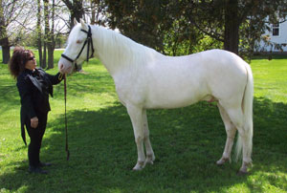
Cremello, with dun factor, Born: April 18, 2006
Paso Fino Horse Assoc. #30,622

Bred for Largo, Sports versatility.
^Sire Sire Dam
Cannrio II →  Cannrio I →Cometa #102061 →Polynesian 1942 & Geisha 1943
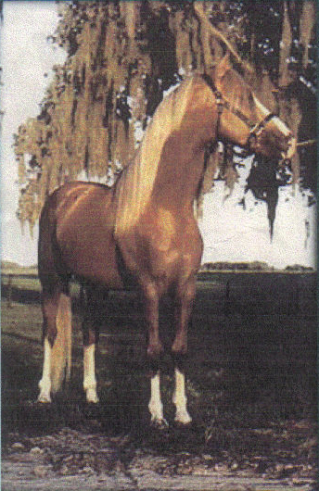
/ #103024 #102069 →La Califa #102066 →Case Ace, 1934 & Lady Glory 1934 Dinamita → →*Nasrullah, 1940 & Segula 42
Coral LaCE → # 103020 → →Count Fleet 40 & Miss Dogwood 39 by *Bull Dog
#70258 Largo
Foundation Sire \
Dama → Cabuyero → →Menow 35 by Pharamond II 1925/Alcibiades 27 & Gaga by*Bull Dog
#102558 #103025 → →War Admiral By Man O'War/Brushup & Businesslike
→ Pluma → →Roman by *Sir Gallahad III /*Buckup & Traffic Court
Gold Spats (TB) # 102339 → →Challedon by*Challenger II & Bird Flower
JC #9314777 Dk. Bay
Coral’s Don Dorado Frio Viento → Triunifo →Batalla #102059 →Dulce Sueno & Felipa
de Vez #80303 / #69883 #102168 →Estrella →Batalla #102059 & Consuelo
SIRE Hija de los Vientos → Maria Luisa →El Huerlano → &
#71246 #71247 Albino →La Crema → &
\
Gitano Viento → Cori →Marinero#102099 → &
#102151 →Santa Elena#102695→ Dulce Sueno & Cordoncillo Alazana
→ Adora →Truinfo #102168 →Batalla #102059 & Estrella#102166 by Batalla
#102916 →Riosa #102480 →Wahoo & Bonita by Licey II & Mora Linda II
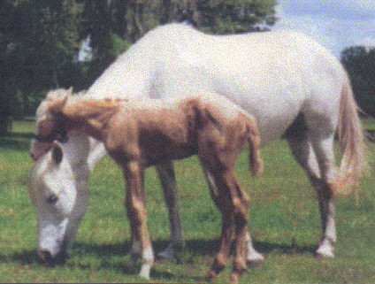
Rey Cometa → Cometa I →Resorte I → Jupiter &
/ #102282 very -- #102375 →La Gaviota &
Lunares69287 good ride, accurate → La Pianola →Califa I → &
# # #102379 →La Nieta → &
foals $ - $ \
mature $ to La Triste → Carnaval → → &
#102383 -- #102773 → → &
→ → → &
Luneta de Omega # → → &
PasoFino Horse Assocc#74974
DAM Sundance → Pea got → → &
#69286 -- #102380 → → &
/ → Madariaga → → &
Cristal # 102381 → → &
#74266 \
Sunset → Caonato → → &
#73629 -- #104264 → → &
→ Maria Bonita → → &
#104265 → → &

Best to Write Joni Lund – Equine Services, or Phone: (701) 652-1986
Manager Rafter J Bar
1295 1st St S
Carrington, ND 58421

email jonisstallionservice@yahoo.com Web site: www.jonilund.com

