<8/2006 DAM For Sale or Lease for Foal
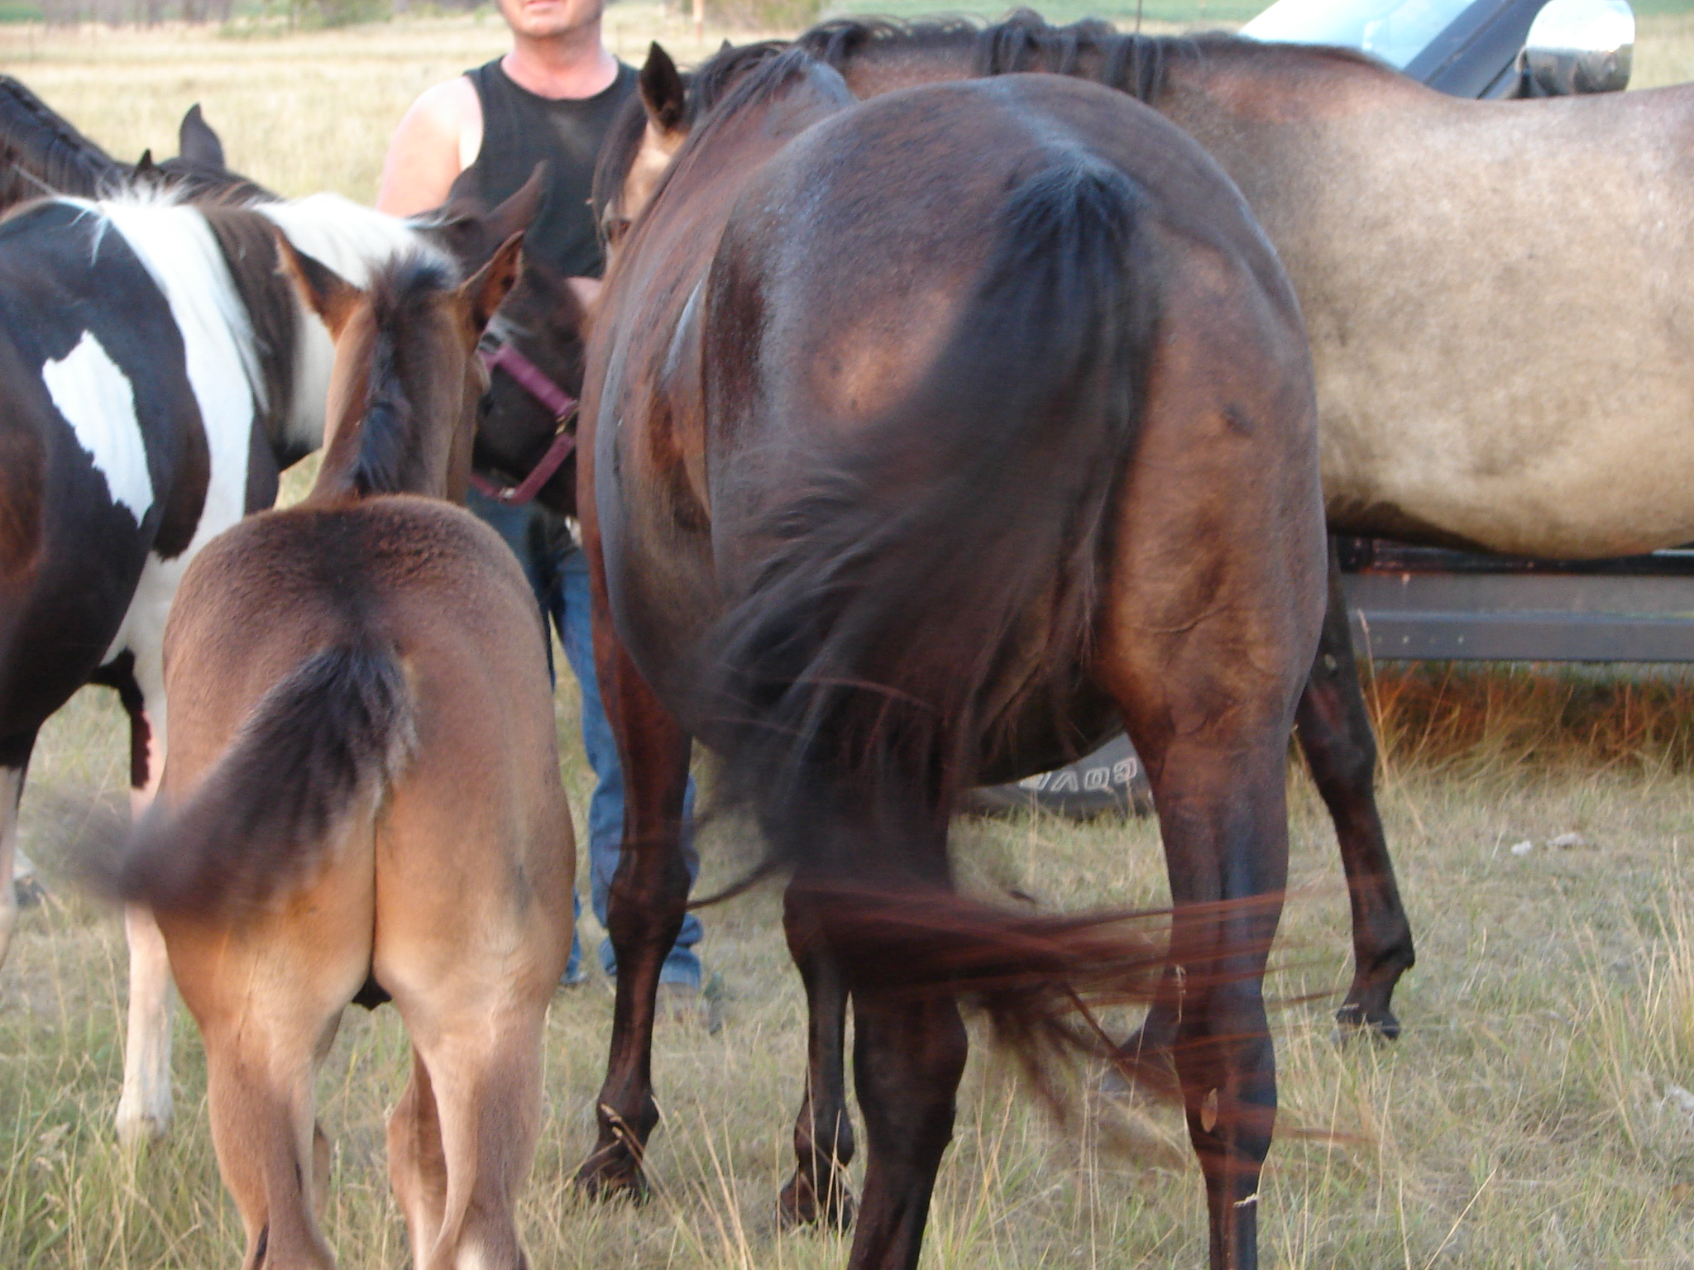
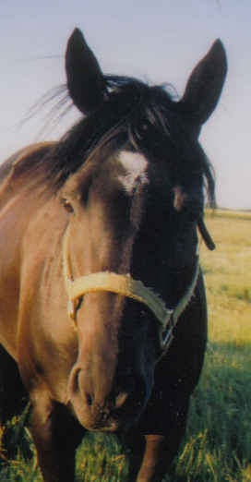
Ms Classic McCue
Dk. Brown, Star& white on Rear heels, looks Black, thick.
American Paint Horse Assoc # 440,650
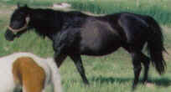
North Dakota Racing Commission #2836
^7/2004 14.3-15 hh Born: 3/27/1998

6/2005> website www.jonilund.com
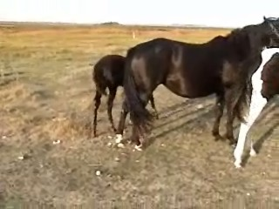
Sire/Dam
Buck McCue Jr Buck McCue Kingfisher unknown
57,140 Black Overo 30180 Black Overo Gypsy McMue Broadmoore Buck/Apache
Sir Mickey McCue Indian Modle Mecapo Sod Buster/Rosie’sPride
86,217 23099 Black T QH Mare QH/QH
Black Overo ?
^7/2006 Blue Fisher Unknown ?
45,636 Black Overo ?
Unknown ?
Trooper Tee McCue
236,047 Black Tob-Overo Coy’s Bonanza Jaguar/Sparky Joann
Emphasis War Leo Bonanza War Leo’s Penny War Leo/gay Chubby
44,745Black Tobiano Q0550414 Sorrel Black Joe Pretty Badgar/painted Jo
Ebony Emphasis EE Black Dart Hank’s EE Show Me Hank’s Koko/Creole Queen
123,740 15771 Black T
Black Tobiano Moolah Bux *Mahmound/Anchors Ahead
Prissy Bux Rulla Bux Miss Uppity *Nasrullah/Nursery School
QX001660 Brown T0000394 Hobo Bo
Prissy Brat Miss Whiskers Frito/Arizona Star
Q0320556
?
Nalees Man *Gallant man(Good Race ) ?
T0001236 Bay T0001114 Bay (Horse) ?
Sid’s Bill Nalee ?
T0013346 T0006872 Bay
?
Always Broke Panacean ?
T0013345 T00010099 Bay ?
Sally Heather ?
Sids Classic T0030854
QH2,495,433Bown Top Deck Lebo ?
Race Horse-Winner, # of x’s? Top Deck Joe Q0476514 Sorrel ?
QH553,858 NowAtASue ?
NQNB1433 ?
Classic Speed
QH843,716 Jayhawker Bar ?
Jay Bar Girl Q0052293 Black ?
QH 365,819 Tonta Lee ?
Q0098514 Palomino ?

Best to Write Joni Lund – Equine Services; 1295 1st ST S; Carrington, ND 58421

Call (701)652-1986 email jonisstallionservice@yahoo.com website www.jonilund.com

A video is available.

Miss Classic McCue - Bloodlines include:

Blue bloodlines on the Sire’s side. Pink bloodlines on the dam’s side.

Trooper Tee McCue 236,047 Black Tob-Overo, did ok as race horse, un promoted much, did well in halter showing.

Sids Classic QH2,495,433Bown Race Horse-Winner, # of x’s?
Emphasis: Pinto Champion. ROM Sire , Multi APHA Halter & Performance Point Earners.

War Leo Bonanza: Arena ROM HI Point Halter, Perf.
Coy’s Bonanza: AAA, AQHA Champion, National High Point Halter Stallion 1963, ROM, Racing & Perfermance.
All-time leading show sire ranked by progeny in open halter & performance as of Jan 1 1999 (8,833.0)
EE Black Dart: Champion Producer
Buck McCue: Grand & Reserve Halter Champion; Sire if 1980 National Western Pleasure Champion,
&1981 Reserve National Western pleasure champion.
.

Kingfisher:

Nalees Man: Good TB race horse.
*Gallant man : Good TB race horse
Always Broke: Good TB race horse.

